
Research Focus: African Christianity
Since the 1930s, starting with Professor Basil J. Matthews, African Christianity has been a core research commitment of the mission faculty in the Boston University School of Theology. This interest is supported by the historical connection between civil rights activism and Africa missions among alumni, and the renowned African Studies Library and African Studies Center of Boston University. Current research interests among Center faculty, visiting researchers, and students include African Christian biography, African mission history, environmentalism, and indigenous Christian movements in southern Africa. The executive office of the Dictionary of African Christian Biography is housed in the Center, and the Shona religion project showcases the photography of M.L. Daneel on African Initiated Churches in Zimbabwe.
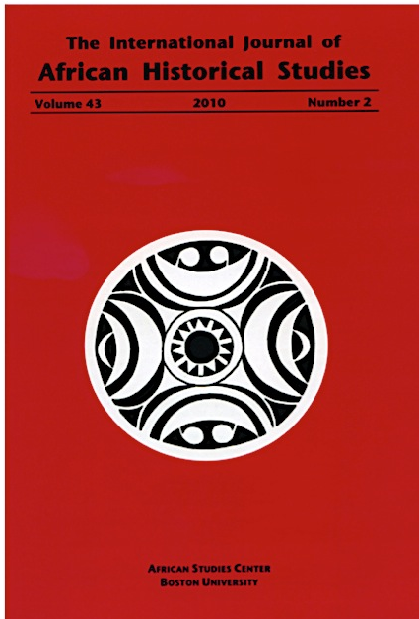
The International Journal of African Historical Studies (IJAHS) is devoted to the study of the African past. The journal publishes three issues each year (April, August, and December). Articles submitted to the journal should be based on original research and framed in terms of historical analysis. Contributions in archaeology, history, anthropology, historical ecology, political science, political ecology, and economic history are welcome.

Subscriptions
Hard copy subscriptions can be purchased on our website (see address below) or by contacting our Business Manager at <ascpub@bu.edu>.

International Journal of African Historical Studies

African Studies Center
Pardee School of Global Studies
Boston University
232 Bay State Road
Boston, MA 02215
Subscribe: www.bu.edu/africa/publications/ijahs


Boston University’s African Studies Library (ASL) is one of the oldest Africana libraries in the country. Founded in 1953, it currently houses over 200,000 print volumes and an increasing number of electronic resources. Its inter-disciplinary collections include African government publications, newspapers and periodicals, maps, ephemera, and various special collections.
The ASL welcomes visiting researchers and students and the general public to consult its collections.
For more information, visit: http://www.bu.edu/library/african-studies/
Journal of  African  Christian  Biography | Vol. 2, No. 2 (April 2017)  Focus:  Aladura Trailblazers (Nigeria)  Gatu and Moratorium (Kenya)
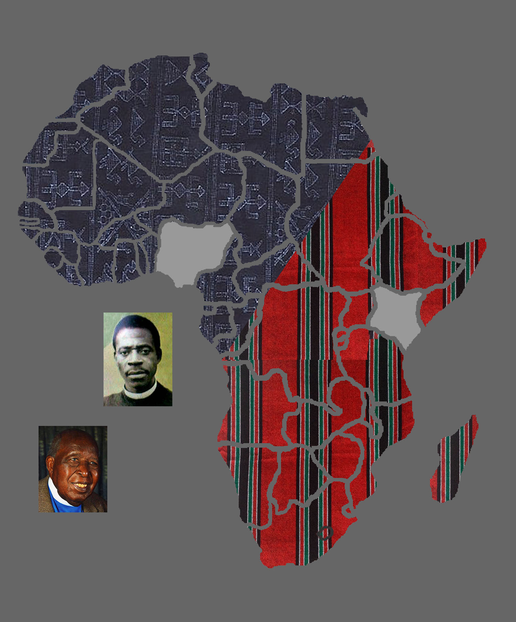
A Publication of the Dictionary of African Christian Biography

