CIDAR MoClo Lab 1 – Build a fluorescent expression plasmid from a DNA part library

Preparation (To be done by students or by educator previous to this class)
- Streak stocks for J23102_AB, BCD2_AB, E1010m_CD, B0015_DE on LB agar with ampicillin
- Streak stock of destination vector DVK_AE on LB agar with kanamycin
- Incubate overnight, select colonies and grow minipreps overnight
- Prep plasmid DNA, quantify, and sequence verify

Experiment
Assemble four DNA parts into a destination vector to create a fluorescent reporter plasmid.
Measure the concentrations of each plasmid and fill in the attached excel file (CIDARMoCloLab.xlsx)
Note: Only adjust white cells. Grey cells auto-calculate.

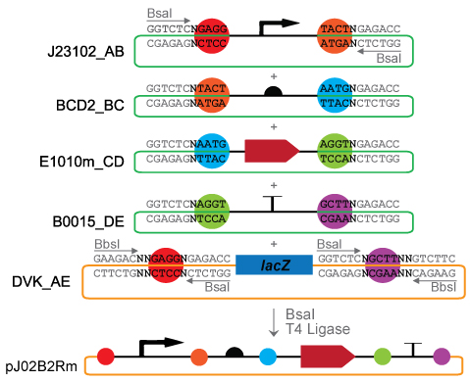
This lab is designed to demonstrate basic MoClo assembly by creating a transcription unit expressing red fluorescent protein (RFP). Using the volumes in the far right column, add water and T4 DNA Ligase Buffer (Promega) to an empty clean PCR tube. Add each part and the destination vector to this tube, pipetting carefully. Add the T4 DNA Ligase and BsaI restriction enzyme last. Briefly mix the solution by flicking the tube or using a brief pulse on a vortex. Spin the tube briefly or shake the liquid to the bottom before placing in the thermocycler.
Quick MoClo Protocol
Step 1 37 C 10’
Step 2 37 C 1.5’
Step 3 16 C 3’
Cycle Step 2-3 10 times
Step 4 50 C 5’
Step 5 80 C 5’
Total Time: 65 minutes
Note: Try duplicate reactions with 5, 10, or 15 cycles and compare cell counts.

When the reaction is finished, use 5 µL of the MoClo reaction and 10 µL of highly competent E. coli cells for a standard heat shock transformation in a clean Eppendorf tube:
Figure 1 Assembly of fluorescent reporter plasmid using four basic parts (promoter, RBS, CDS, terminator) and a Destination Vector.
- Place frozen competent cells on ice to thaw. Avoiding pipetting as much as possible.
- Add 5 µL of MoClo reaction to cells, flick tube to mix. Leave on ice for 5’.
- Heat shock cells by placing in a 42 C water bath for 90 seconds then return to ice.
- Add 200 µL SOC or LB media and shake at 37C for 10-60 minutes.
- Plate on LB agar plates supplemented with 80 μL of 20 mg/μL 5-bromo-4-chloro-3-indolyl ß-D-galactopyranoside (X-GAL), 100 μL of 0.1M isopropyl-ß-D-thiogalactopyranoside (IPTG) & kanamycin. Incubate plates overnight at 37 C.

Analysis (before experiment)
What color will the colonies be if they contain a correct pJ02B2Rm_AE plasmid? Why?

What would a white colony mean?

What would a blue colony mean?

Analysis (after experiment)
How many colonies grew? How many of each color?

Calculate the efficiency of the reaction (# of white colonies / # of total colonies).

Compare these numbers to data from other students and describe this analysis.

What would happen if you repeated the reaction with more than one CDS part (ex. RFP and GFP) in a single reaction?

Answers

Analysis (before experiment)
What color will the colonies be if they contain a correct pJ02B2Rm_AE plasmid? Why?
Red, as the fluorescence from RFP is visible in normal room lighting. White is also an acceptable answer as the red fluorescence is only visible when expressed at high levels.

What would a white colony mean?
White colonies result from the removal of the LacZ fragment. Generally a white colony is a correctly assembled plasmid, however some artifacts which remove the LacZ fragment but fail to correctly assemble the desired plasmid will also result in a white colony.

What would a blue colony mean?
Blue colonies are caused by the expression of LacZ (betagalactosidase) induced by IPTG and the resulting metabolism of X-gal into a blue chromophore. Blue colonies are destination vectors.

Analysis (after experiment)
How many colonies grew? How many of each color?
This number will vary. Normal MoClo reactions produce 100-500 colonies per plate, depending on the competent cells, recovery time and the quality of the MoClo reaction. Low numbers of colonies are likely due to improper handling of the competent cells or a poor quality MoClo reaction (pipetting error, incorrect components).

Calculate the efficiency of the reaction (# of white colonies / # of total colonies).
This number will depend on the plates. Under good conditions, MoClo reactions are >95% efficient.

Compare these numbers to data from other students and perform.
Suggest students attempt to do statistical analysis, compare between groups of students and analyze the potential causes of variation.

What would happen if you repeated the reaction with more than one CDS part (ex. RFP and GFP) in a single reaction?
This question leads into the next lab, Multiplex MoClo. Students should be able to understand that the results would be some GFP expressing cells and some RFP expressing cells as both possible output plasmids would be made. Higher level understanding: Mixed parts should be added in lower concentrations such that the total of that part type is 10fmol.

CIDAR MoClo Lab 2 – Multiplex Modular Cloning

Preparation (To be done by students or by educator previous to this class)
- Streak stocks for J23102_AB, J23102_EB, J23106_AB, J23116_AB, BCD2_AB, eBFP2_CD, E0040m_CD, E1010m_CD, B0015_DE, B0015_DF on LB agar with ampicillin
- Streak stock of destination vector DVK_AE and DVK_EF on LB agar with kanamycin
- Incubate overnight, select colonies and grow minipreps overnight
- Prep plasmid DNA, quantify, and sequence verify

Experiment
Assemble multiple DNA parts in multiplex reactions to assemble small plasmid libraries and analyze resulting ratios.
Measure the concentrations of each plasmid and fill in the attached excel file (CIDARMoCloLab.xlsx)
Note: Only adjust white cells. Grey cells auto-calculate.
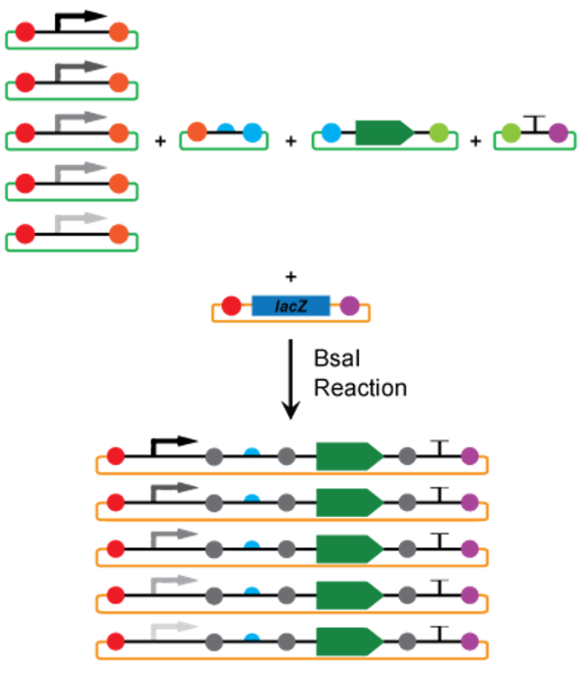
This lab is designed to demonstrate multiplexed MoClo reactions to create plasmid libraries. For ease of measurement, we are again using fluorescent proteins. Using the calculation sheet as before, add all components to clean tubes, performing three separate MoClo reactions. Pay attention to the fusion sites. Briefly, mix the solution by flicking the tube or using a brief pulse on a vortex. Spin the tube briefly or shake the liquid to the bottom before placing in the thermocycler.
Quick MoClo Protocol
Step 1 37 C 10’
Step 2 37 C 1.5’
Step 3 16 C 3’
Cycle Step 2-3 10 times
Step 4 50 C 5’
Step 5 80 C 5’
Figure 2 Assembly of multiple plasmids simultaneously using Multiplex MoClo. Any part type can be multiplexed, or more than one part to create a library of plasmids in a single reaction.
Total Time: 65 minutes
Note: Try duplicate reactions with 5, 10, or 15 cycles and compare cell counts.

When the reaction is finished, use 5 µL of the MoClo reaction and 10 µL of highly competent E. coli cells for a standard heat shock transformation in a clean Eppendorf tube as before.
- Plate on LB agar plates supplemented with 80 μL of 20 mg/μL 5-bromo-4-chloro-3-indolyl ß-D-galactopyranoside (X-GAL) and 100 μL of 0.1M isopropyl-ß-D-thiogalactopyranoside (IPTG) and appropriate antibiotic. Incubate plates overnight at 37 C.
- Once grown, select colonies and inoculate a 96 well plate using toothpicks. Touch a toothpick to a single colony, then shake the toothpick in a well carefully to dislodge cells into the media. Avoid dark blue (LacZ) clones.
- Grow these cultures overnight at 37C in a shaking incubator.
- Measure fluorescence and OD with a plate reader (red, green, and blue fluorescence settings)

Analysis (before experiment)
What color(s) will the colonies be on each plate? What percentages of each color do you expect to see?
MMC1 - pJ02B2X_EF

MMC2 - pJXB2Rm_AE

MMC3 - pJ0XB2X_AE

What factors could influence these percentages?

Analysis (after experiment)
How many colonies grew? How many of each color?
MMC1 - pJ02B2X_EF

MMC2 - pJXB2Rm_AE

MMC3 - pJ0XB2X_AE

Calculate the efficiency of the reaction (# of white colonies / # of total colonies) and the ratios of colors on each plate.

Using the plate reader data, identify the different populations in the Multiplex MoClo reactions. Create a chart listing the number of colonies in each population. How can you differentiate the high, medium, and low expression fluorescence colonies of the same color?

Consider how this might be useful in a biology research setting. List some possibilities.

Answers

Analysis (before experiment)
What color(s) will the colonies be on each plate? What percentages of each color do you expect to see?
MMC1 - pJ02B2X_EF
Colonies will be either red, green, white, or dark blue (LacZ). The eBFP colonies won’t be visibly blue though students likely won’t know this. Again, the answer “white” for fluorescent colonies is also correct as only high expression fluorescence is visible. Dark blue colonies indicate left over destination vector.
MMC2 - pJXB2Rm_AE
Colonies will be red, lighter shades of red, white, or blue (LacZ). Lower expression colonies will appear white. Dark blue colonies indicate left over destination vector.
MMC3 - pJ0XB2X_AE
Colonies will be shades of red or green in visible light. Blue fluorescent colonies aren’t visible in white light. Lower expression and blue fluorescence colonies will appear white. Dark blue colonies indicate left over destination vector.
What factors could influence these percentages?
Pipetting accuracy. Accuracy of the miniprep concentrations. Quality of minipreps.

Analysis (after experiment)
How many colonies grew? How many of each color when measured on the plate reader?
MMC1 - pJ02B2X_EF
Should expect equal ratios of red, blue and green fluorescent colonies.
MMC2 - pJXB2Rm_AE
Should be able to identify three populations of red expression colonies, high, medium, and low levels of fluorescence. These correlate to the J23102 (high), J23106 (medium) and J23116 (low) promoters.
MMC3 - pJ0XB2X_AE
Should be able to identify three populations of each color, high, medium, and low levels of fluorescence. These correlate to the J23102 (high), J23106 (medium) and J23116 (low) promoters.
Calculate the efficiency of the reaction (# of white colonies / # of total colonies) and the ratios of colors on each plate.
Ideally >95% white colonies. MMC 1 should be near 1:1:1 ratio of red:green:blue, MMC 2 should be nearly 1:1:1 ratio of high:medium:low red expression; MMC 3 should be approximately 1:1:1:1:1:1:1:1:1.

CIDAR MoClo Lab 3 – Device construction from two transcription units

Preparation (To be done by students or by educator previous to this class)
- Streak stock of destination vector DVA_AF on LB agar with ampicillin
- Incubate overnight, select colonies and grow minipreps overnight
- Prep plasmid DNA, quantify, and sequence verify

Experiment
Assemble two transcription units in a destination vector to create a dual color expression device.
Measure the concentrations of each plasmid and fill in the attached excel file (CIDARMoCloLab.xlsx)
Note: Only adjust white cells. Grey cells auto-calculate.

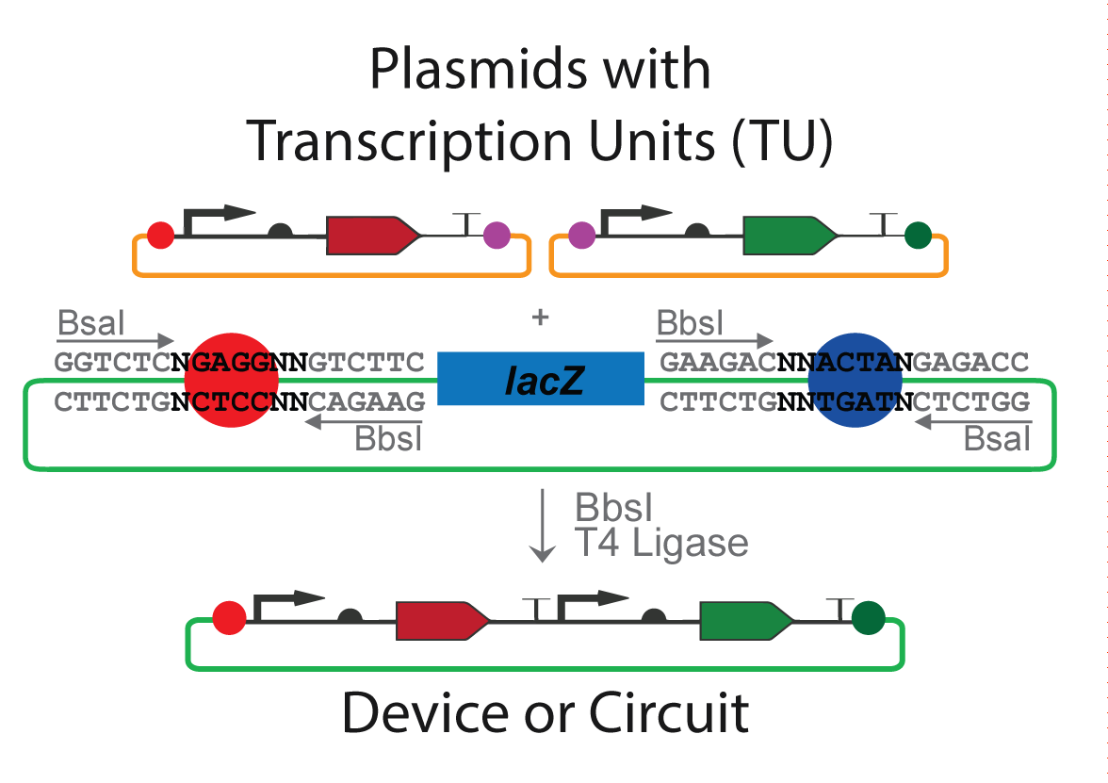
This lab is designed to assemble two transcription units (one expressing red fluorescent protein or RFP, and the other expressing green fluorescent protein or GFP) into a single destination vector to create a two part device. Using the calculation sheet as before, add all components to a clean tube. Briefly, mix the solution by flicking the tube or using a brief pulse on a vortex. Spin the tube briefly or shake the liquid to the bottom before placing in the thermocycler.
Quick MoClo Protocol
Step 1 37 C 10’
Step 2 37 C 1.5’
Step 3 16 C 3’
Cycle Step 2-3 10 times
Step 4 50 C 5’
Step 5 80 C 5’
Total Time: 65 minutes
Note: Try duplicate reactions with 5, 10, or 15 cycles and compare cell counts.
Figure 3 Assembly of multiple transcription units into a dual expression device expressing both RFP and GFP.

When the reaction is finished, use 5 µL of the MoClo reaction and 10 µL of highly competent E. coli cells for a standard heat shock transformation in a clean Eppendorf tube as before.
- Plate on LB agar plates supplemented with 80 μL of 20 mg/μL 5-bromo-4-chloro-3-indolyl ß-D-galactopyranoside (X-GAL) and 100 μL of 0.1M isopropyl-ß-D-thiogalactopyranoside (IPTG) and ampicillin. Incubate plates overnight at 37 C.
- Once grown, select colonies and inoculate a 96 well plate using toothpicks. Touch a toothpick to a single colony, then shake the toothpick in a well carefully to dislodge cells into the media. Avoid dark blue (LacZ) clones.
- Grow these cultures overnight at 37C in a shaking incubator.
- Measure fluorescence and OD with a plate reader (red and green fluorescence settings)

Analysis (before experiment)
What color(s) will the colonies be on the plate?

Analysis (after experiment)
How many colonies grew? What colors?

Calculate the efficiency of the reaction (# of white colonies / # of total colonies) and color ratios.

Using the plate reader data, identify the ratio of red and green expression and discuss the reasons for these values.

How does the red value relate to the corresponding red value for the same transcription unit in the previous experiment? How about the green values? Explain why these values are as they are.

Consider how this might be useful in a biology research setting. List some possibilities.

Answers

Analysis (before experiment)
What color(s) will the colonies be on the plate?
Colonies will be expressing both red and green resulting in a yellow/orange color. Colonies may appear more white depending upon incubation time, and blue colonies indicate original destination vectors.

Analysis (after experiment)
How many colonies grew? What colors?
>100 colonies ideally. Most should be red/green mixed; a few blue destination vectors are likely.

Calculate the efficiency of the reaction (# of white colonies / # of total colonies).
>95%,

Using the plate reader data, identify the ratio of red and green expression and discuss the reasons for these values.
Theoretically, expression would be equal since promoter and RBS parts are the same. However, in practice, the _AE plasmid tends to express at higher levels. Therefore it would be expected that students see more red fluorescence than green. Another factor, though, is that red and green fluorescence cannot be compared directly due to differences in the measurement parameters (filters, lasers).

How does the red value relate to the corresponding red value for the same transcription unit in the previous experiment? How about the green values? Explain why these values are as they are.
Values should be similar, however the difference in the vector will influence expression.

Consider how this might be useful in a biology research setting. List some possibilities.
Creation of large genetic devices from modular parts allows for easy design and iteration of complex devices.

Notes to educator:
These experiments are based upon the following publications:
Iverson, S.V., T. Haddock, J. Beal, D. Densmore. CIDAR MoClo: Improved MoClo Assembly Standard and New E. coli Part Library Enables Rapid Combinatorial Design for Synthetic and Traditional Biology. ACS Synth Biol (2015) – http://pubs.acs.org/doi/abs/10.1021/acssynbio.5b00124
Iverson, Sonya. Improved modular multipart DNA assembly, development of a DNA part toolkit for E. coli, and applications in traditional biology and bioelectronic systems. Thesis dissertation. Boston University (2016)
More information can be found at www.cidarlab.org/moclo
The CIDAR MoClo Library is available from Addgene - #1000000059. The full list of parts is found below.

Consider streaking all plasmids and doing all experiments alongside or before the class to have a ‘control’ set. The plasmids used in Lab 3 are also included as controls in the 96-well plate. See the list on the following pages.
Feel free to adapt or modify this basic lesson plan. It is meant primarily as a guide. Please contact siverson@bu.edu with any questions.
Table ‎A-7 CIDAR MoClo Library part list. All basic parts, vectors, and fluorescent control plasmids are listed here with their Addgene and CIDAR-ICE ID numbers and Benchling location. The full collection can be requested from Addgene (#1000000059).

