Environmental Reconstruction and Wood Use at Late Chalcolithic Çamlıbel Tarlası, Turkey

John M. Marston^{a,b,*}, Peter Kováčik^{b}, and Ulf-Dietrich Schoop^{c}

ª Program in Archaeology, Boston University, 675 Commonwealth Avenue, Boston, MA 02215, USA
^{b} Department of Anthropology, Boston University, 232 Bay State Road, Boston, MA 02215, USA
^{c} School of History, Classics, and Archaeology, University of Edinburgh, William Robertson Wing, Old Medical School, Teviot Place, Edinburgh EH8 9AG, Scotland
* Corresponding author: marston@bu.edu

For submission to special issue of Quaternary International titled “Charcoal Science in Archaeology and Palaeoecology”

Abstract

Çamlıbel Tarlası is a short-lived, mid 4th millennium BCE Chalcolithic archaeological site in northern central Anatolia, modern Turkey, with evidence for both intensive metallurgy and permanent occupation. Analysis of a wood charcoal assemblage from the site, totaling 2815 charcoal fragments, is the first from this period and region. Anthracological analysis indicates that the primary fuel wood used was deciduous oak, which comprised nearly 90% of identifiable fragments. We find little evidence of differences in wood species used for different functions or over time; however, a significant trend towards the increased use of large-diameter branch or trunk wood over time is noted both for oak and other minor taxa. We reconstruct a dense oak-dominated woodland in the vicinity of the site at the time of first use, with increased forest clearance over time, due to either diminished fuel availability or agricultural expansion, or a combination of the two. An intensification in metallurgical activity in later periods of occupation may have increased demand specifically for large-diameter wood.

Keywords

Wood Charcoal, Chalcolithic, Anatolia, Oak, Dendroanthracology, Metallurgy

1. Introduction

Wood charcoal assemblages from archaeological sites have the potential to reconstruct woodland communities no longer extant today and to identify the variety of ways in which inhabitants of a site procured and used wood (Asouti and Austin, 2005; Chabal, 1992; Marston, 2009). Special purpose sites, in which inhabitants were engaged in specific industries, may produce distinctive archaeological wood assemblages, depending on the nature of the industry, its specific technologies, and wood availability in the local area. The study of archaeological wood charcoal assemblages from such sites, therefore, offers insight into industrial technologies and adaptations over time to changing resource availability.
The Chalcolithic period site of Çamlıbel Tarlası, in highland central Anatolia (modern Turkey), offers an excellent case study for exploring wood use at an early metallurgical site. The short occupation period of Çamlıbel Tarlası, with charcoal identified from five distinct use phases, gives an opportunity to glimpse how wood use in copper production changed with fine chronological resolution, distinguishing periods of as little as 50 years. We present here the analysis of wood charcoal fragments from Çamlıbel Tarlası to examine fuel management at the site and reconstruct woodland communities in the area during the Late Chalcolithic occupation. Comparison of wood charcoal data with previously published analyses of architecture (Schoop, 2015), metal production (Rehren and Radivojević, 2010; Schoop, 2011), farming (Papadopoulou and Bogaard, 2012; Stroud, 2016), and animal husbandry (Bartosiewicz and Gillis, 2011; Bartosiewicz et al., 2013; Pickard et al., 2017; Pickard et al., 2016) offer additional insights into integrated strategies of land-use management employed during the use life of this prehistoric site.

2. Çamlıbel Tarlası

2.1. Site description, chronology, and geography

Çamlıbel Tarlası is a Late Chalcolithic site located just 2.5 km west of the ancient Hittite capital Hattuša in north-central Anatolia (Figure 1), in the province of Çorum, Turkey. Situated approximately 3 km from the main Budaközü Plain on a low, stepped plateau within the narrow side valley of the Karakeçili Deresi stream, the site represents a small, short-lived occupation. Excavations at Çamlıbel Tarlası were conducted between 2007 and 2009 as a cooperation between the Boğazköy Expedition of the German Archaeological Institute (Deutsches Archäologisches Institut) and Edinburgh University (Schoop, 2011). The aims of the project included 1) reconstruction of regional environmental conditions in prehistoric times, including identifying the possible presence of woodlands and wetlands; 2) finding evidence for economic adaptations to these conditions; and 3) producing robust chronological information for the prehistory of this area (Schoop, 2008, 2011). Following an initial, lengthy period of regular visits to the site focused on metallurgical activity (ÇBT I), three episodes of permanent residence intermitted with three additional phases of ephemeral use (Table 1).

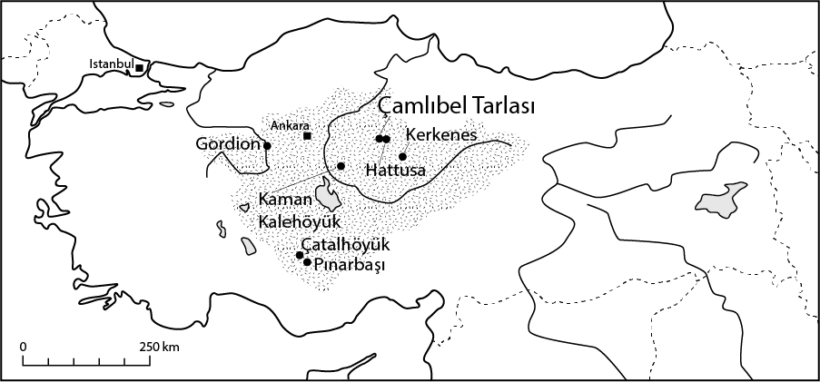

Fig. 1. Location of Çamlıbel Tarlası and other sites mentioned in text; hatched area denotes Central Anatolian Plateau.

Phase | Characteristic features
TPEU | Terminal phase of ephemeral use: fragmentary burials in plough zone
ÇBT IV | Habitations, large courtyard with evidence of slag processing, slag, crucibles
SPEU | Second phase of ephemeral use: seasonal presence, bowl furnaces, ore
ÇBT III | Large, free-standing buildings, “Burnt House,” crucibles, copper slag
FPEU | First phase of ephemeral use: seasonal presence, bowl furnaces, ore
ÇBT II | Dense architecture, room clusters, internal domed ovens, many infant graves
ÇBT I | No habitation structures, water course, seasonal use?, bowl furnaces, copper ore
 | Sterile soil/bedrock
Table 1. Phases of activity at Çamlıbel Tarlası, in stratigraphic position.

Phase ÇBT I is particularly interesting, as the deposits dating to this phase consist almost exclusively of thick layers of charcoal-rich ash (Figure 2). These ashy deposits appear to have been the result of an as yet unidentified industrial process dependent on wood or charcoal combustion in which waste materials, including ash and charcoal, were washed downslope across the site and accumulated locally to considerable depth. The characteristic alternation of weathered and unweathered layers of the same material suggests repeated, possibly seasonal, visits to the site to engage in the same pyrotechnical activity (Schoop, 2011:55-55, 2015:50-52).

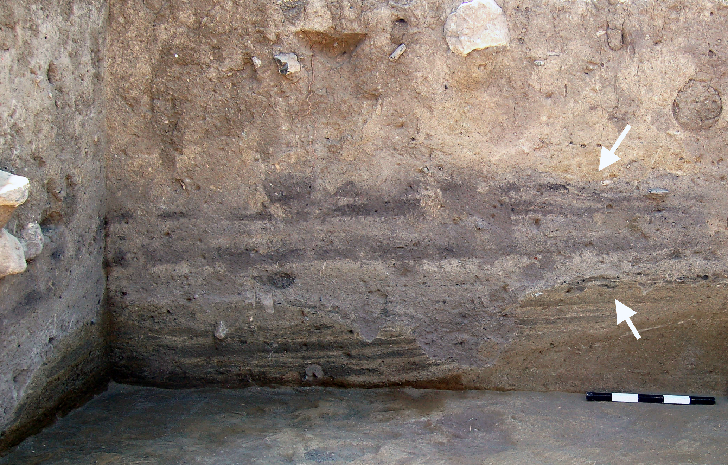

Figure 2. Layered ÇBT I ash and charcoal deposits in section. Scale bar is 0.5 m in length.

Four seeds from use phases ÇBT II and ÇBT IV were originally radiocarbon dated, producing dates ranging between 3650 and 3375 cal BCE (Pickard et al., 2016). The use life of the site was likely shorter, however, given that these dates intersect a plateau on the radiocarbon calibration curve; a more likely range of site occupation based on these dates has been given as ca. 3590–3470 cal BCE (Schoop, 2015:50; Schoop et al., 2009:66-67). Two new radiocarbon dates from the onset of phase ÇBT I are now available. A simple Bayesian model that treats the two ÇBT I dates as earlier than the ÇBT II and those as earlier than the ÇBT IV dates renders a 95% confidence interval of roughly 3665-3515 cal BCE for phases ÇBT I through ÇBT IV, a period of 150 years at most (Table 2).

 | Radiocarbon Age (BP) | Calibrated, Unmodelled (BCE/CE) |  |  | Calibrated, Modelled (BCE/CE)
 |  | from | to | % | from | to | %
Boundary Start |  |  |  |  | -3715 | -3534 | 95.4
Phase ÇBT I
R_Date OxA-36173 | 4833 ± 34 | -3696 | -3527 | 95.4 | -3663 | -3533 | 95.4
R_Date OxA-36174 | 4829 ± 33 | -3694 | -3526 | 95.4 | -3661 | -3533 | 95.4
Boundary ÇBT I/II |  |  |  |  | -3650 | -3531 | 95.4
Phase ÇBT II
R_Date OZK 887 | 4780 ± 30 | -3641 | -3519 | 95.4 | -3640 | -3531 | 95.4
R_Date OZK 886 | 4725 ± 35 | -3635 | -3376 | 95.4 | -3638 | -3529 | 95.4
Boundary ÇBT III |  |  |  |  | -3635 | -3527 | 95.4
Phase ÇBT IV
R_Date OZK 883 | 4790 ± 30 | -3645 | -3521 | 95.4 | -3634 | -3521 | 95.4
R_Date OZK 882 | 4735 ± 40 | -3636 | -3377 | 95.4 | -3634 | -3516 | 95.4
Boundary End |  |  |  |  | -3635 | -3474 | 95.4

Table 2. Bayesian model of published radiocarbon dates from Çamlıbel Tarlası (dates OZK 882, 883, 886, 887 from Schoop et al., 2009; dates OxA-36173 and OxA-36174 previously unpublished) using Oxcal 4.3 (Ramsey, 2017) and IntCal13 (Reimer et al., 2013).

Geomorphological study of the region by Ben Marsh (2010) illustrates how the landscape of Çamlıbel Tarlası has changed, both during settlement of the site and following site abandonment. He dates landscape disturbance to the earliest phases of site settlement, continuing well past the abandonment of Çamlıbel Tarlası through at least the Byzantine period, based on interbeddings of eroded soils with dated archaeological deposits (Marsh, 2010:204-206). Heavily eroded soils, which form terraces along the neighboring Karakeçili Deresi stream, attest to widespread loss of topsoil following human clearance of native vegetation. This erosion left hillslope soils thin and less productive, and transformed landscape features from wide, low-gradient hillslopes to steeper slopes cut by sharp erosion scars, today as much as 20 m in depth. Such changes reduced landscape productivity in multiple ways: eroded slopes became less productive, high-quality valley soils were buried in coarse sediments, and sedimentation of fine silts along streams produced poorly drained soils and fostered wetlands at the expense of arable soils (Marsh, 2010:203). Based on these observations, we infer that today’s landscape of steep hills and steppe vegetation was a gentler, more stable landscape of wooded hills at the time of settlement. Wood charcoal analysis provides further insight into the extent and composition of such woodlands.

2.2. Environmental archaeology at Çamlıbel Tarlası

Zooarchaeological research has identified local animal husbandry at Çamlıbel Tarlası focused on cattle, pigs, and caprines (sheep more than goat). Together, these taxa comprise 97% of the identified faunal remains (by NISP count; Bartosiewicz and Gillis, 2011). Comparing animal taxa by weight, cattle provided the majority of the meat eaten onsite, at 60% of the assemblage; pigs supplied another 28%, and sheep most of the rest. Sheep bones outnumber those of goats nearly 8 to 1. Bartosiewicz and Gillis (2011:78) infer that the frequency of pigs in the archaeological assemblage implies a much wetter and forested environment than today during the Late Chalcolithic. Pigs were slaughtered at relatively young ages, while cattle and sheep were kept to old ages, implying use for dairy, traction (cattle), and/or wool (sheep) (Bartosiewicz and Gillis, 2011). Pickard et al. (2016) use human bone stable isotope results, together with zooarchaeological evidence and the presence of churns, to infer that occupants of Çamlıbel Tarlası made extensive use of dairy products. Morphometric and ancient DNA studies of pigs from the site indicate that there was likely some genetic introgression of native Anatolian boars into the pig lineage at some point during the Neolithic expansion of pig husbandry into Anatolia (Ottoni et al., 2013), but the phenotype of pigs at Çamlıbel Tarlası falls well within the boundaries of domesticates, with no indication of boar-like physical characteristics (Bartosiewicz et al., 2013).
Recent stable isotopic study of pigs, caprines, and cattle from the site gives insight into the diet of these animals (Pickard et al., 2017; Pickard et al., 2016). Notably, Pickard and colleagues identified a similar isotopic space (δ¹³C and δ¹⁵N) in the diet of pigs and caprines (both sheep and goats), indicating they ate similar diets that consisted entirely of C₃ plants; cattle, however, ate a more variable diet, in both δ¹³C and δ¹⁵N, and a diet more enriched in δ¹³C than pigs and more enriched in δ¹⁵N than caprines (Pickard et al., 2017:1358). These results suggest that pigs were unlikely to have been kept in sties and fed domestic refuse, but instead were either herded or free-ranging. The increased diversity of cattle diet may be a function of greater mobility of those animals, such that they encountered a broader range of environments, including those with C₄ plants. All agricultural products recovered from the site are C₃ pathway plants, as detailed below.
Flotation samples collected from all phases were processed to recover archaeobotanical remains, totaling 420 samples, although only a portion have been analyzed to date. Initial archaeobotanical analyses from 2012 indicated local agricultural production dependent on the cultivation of hulled barley and glume wheats (emmer and einkorn), five pulse species, and flax (Papadopoulou and Bogaard, 2012). Additional archaeobotanical analysis conducted by Stroud (2016) on a total of 105 flotation samples extended the suite of crops used at the site to include definitive identification of “new type” glume wheat and free threshing wheat (either bread or hard wheat, the seeds of which are indistinguishable). A significant array of wild plants also was identified, several of which are considered segetal weeds (e.g., Silene and Lolium) associated with flax cultivation; Galium is another frequent segetal weed. Other agricultural activities identified at this site included the processing of glume wheats, based on abundant wheat chaff. Limited recovery of dung-derived wild plant seeds at Çamlıbel Tarlası suggests other fuel sources, such as wood, were readily available (Stroud, 2016:422).

2.3. Comparative charcoal studies from central Anatolia

Analyses of charcoal from central Anatolian sites are limited, especially for the Chalcolithic. Only one other Chalcolithic charcoal assemblage has been published for the region, in southwestern central Anatolia at the site of Pınarbaşı (Asouti, 2003). This assemblage, however, dates considerably earlier than Çamlıbel Tarlası, with a latest date of 4725-4400 cal BCE, at least 700 years earlier than ÇBT I (Asouti, 2003:1186). Charcoal has been published from earlier Neolithic sites (Çatalhöyük: Asouti, 2005, 2012; Asouti and Hather, 2001) and later Bronze and Iron Age sites (Kaman-Kalehöyük: Wright et al., 2015; Wright et al., 2017; Gordion: Marston, 2017; Miller, 1999, 2010) to the south and west of Çamlıbel Tarlası, as well as very small Iron Age assemblages from the nearby sites of Hattusa and Kerkenes (Dörfler et al., 2000:377). These serve as the most useful comparanda for Çamlıbel Tarlası, but no wood assemblages contemporary with the site have been published to date from central Anatolia (Figure 1).

3. Materials and methods

3.1. Sampling and subsampling

A total of 420 sediment samples, planned at 40 L in volume where possible, collected during the 2007-2009 field seasons were floated by excavation personnel using a modified flotation machine similar to French’s (1971) Ankara machine (Papadopoulou and Bogaard, 2012:124). Of these, 105 were selected for analysis by Stroud (2016) and subsequently made available for this study. The dried light fractions were exported to Oxford University where they were passed through a series of graduated geological screens (4-mm, 2-mm, 1-mm, and 0.3-mm openings) and scanned and sorted by Elizabeth Stroud (Stroud, 2016:113-114). Charcoal pieces larger than 2 mm were sorted from the rest of the light fraction, and the total charcoal larger than 2 mm was weighed. These charcoal remains were then exported to the Environmental Archaeology Laboratory (EAL) at Boston University for anthracological analysis.
Flotation samples are numbered in a binomial system, with the first number that of the context, and the second a unique sample identifier. Some contexts are represented by multiple flotation samples reflecting the same behavioral event, mainly from internal floors and external use surfaces, which were sampled in gridded 1 m squares (Stroud, 2016). One sample (911-5318) did not yield any charcoal and thus was excluded from further anthracological analysis. As a result, 104 samples were available for anthracological analysis, which represent material from the four use phases and one intermediate ephemeral use phase: ÇBT I, ÇBT II, FPEU, ÇBT III, and ÇBT IV (Table 3). Two samples contain mixed or indistinct contexts that cannot be distinguished among phases; these are not included in the phase-by-phase analysis but are included in site-wide totals and analyses below. Material pulled as charcoal but identified as non-charcoal (e.g., parenchymatous tissue) has been removed from this table and subsequent analyses, but is recorded in the electronic supplementary data table (ESM 1).

Phase | Samples | Fragments
ÇBT IV | 16 | 419
ÇBT III-IV | 1 | 2
ÇBT III | 37 | 1029
FPEU | 4 | 132
ÇBT II | 23 | 485
ÇBT I-II | 1 | 40
ÇBT I | 22 | 708
Total | 104 | 2815

Table 3. Sample and total examined charcoal fragment counts by phase.

3.2. Identification

Initially we planned to identify at least 40 charcoal fragments from each sample after Kováčik and Cummings (2018), however, not all samples contained at least this number of charcoal fragments. Only 46 of the 104 samples (44%) contained 40 or more fragments of charcoal. Some samples were extremely small, containing only a single fragment or a few charcoal pieces. Between 10 and 39 fragments were present in 38 samples (37%), while 20 samples (19%) yielded fewer than 10 fragments each. In samples with fewer than 40 charcoal pieces, all fragments were examined. For samples with more than 40 fragments, we generally identified only the first 40 charcoal pieces randomly pulled from the sample, although in a few samples we slightly exceeded this total, up to 45 total examined fragments.
Charcoal pieces were broken (using hand, tweezers, and/or a razor blade) to expose fresh transverse, radial, and tangential sections, then examined using a binocular microscope at a magnification of up to 40x and with an incident-light microscope at magnifications of 50x to 400x. Charcoal remains were identified to genus or family level by comparison with modern reference specimens curated at the EAL and using published identification manuals (Akkemik and Yaman, 2012; Crivellaro and Schweingruber, 2013; Fahn et al., 1986; Schweingruber, 1990a, b; Schweingruber et al., 2011, 2013). Images of each charcoal type were obtained using a PhenomWorld desktop scanning electron microscope (SEM) in the Department of Earth and Environment at Boston University.

3.3. Recording Dendroanthracological Data

Dendroanthracological data, including curvature degree, presence/absence of pith, presence/absence of bark, number of growth rings, and ray width were recorded. Only the curvature degree data are analyzed in this article, however, as they are of primary importance in identifying wood procurement strategies. The full suite of dendroanthracological data can be used in future study of the proportions of shrubby vs. large trunk wood in these deposits and in inferring use of wood acquisition techniques including coppicing (Deforce and Haneca, 2015; Wright, 2018). Although the condition of each charcoal fragment, such as vitrification and friability, was recorded, these data were not quantified further.
The curvature degree recorded was qualitative, with each wood fragment assigned to one of three classes (following the terminology of Asouti et al., 2018, after Marguerie and Hunot, 2007): CD1 (large diameter stem or trunk wood), CD2 (intermediate diameter stem), and CD3 (small diameter stem: twigs, small round wood, and the innermost portion of larger branches). Critically, categories CD2 and CD3 include the inner portion of larger wood or branches, rather than only small diameter branches and twigs. Marguerie and Hunot (2007) and Wright (2018) noted that combination of three characteristics—presence of bark, presence of pith, and wood diameter Category 1 (0-50 mm)—indicates wood charcoal that represents either a twig or a small branch. Our analysis, however, did not include measurement of wood diameter, as this technique is time consuming and curvature degree provides a useful measure of the same variable (Marguerie and Hunot, 2007). Following the curvature degree nomenclature of Asouti et al. (2018), we noticed that classes CD2 and CD3 are difficult or impossible to distinguish when examining charcoal smaller than 4 mm, and when charcoal fragments include less than one entire growth ring. Such specimens were not assigned to a CD class.
In addition, we also recorded whether charcoal fragments originated from knots. These fragments were assigned the class "knot”. Only categories CD1, CD3, and “knot” were observed in Çamlıbel Tarlası charcoal assemblages, save a single CD2 fragment of Corylus; because this piece is the only fragment in the assemblage assigned CD2 curvature, it is grouped with category CD3 in the analyses that follow.

3.4. Quantification

Full charcoal data are included as a spreadsheet (Electronic Supplementary Material 1). Charcoal fragments that share the same sample and characteristics (number of growth rings, presence of tyloses, size, curvature degree, etc.) were grouped as a single subsample, with the number of fragments and total weight recorded. Each charcoal subsample, whether it contains one or several pieces of charcoal, was assigned a unique subsample number. Identified taxa in the anthracological dataset were quantified using percentage abundance by phase, which was used to produce anthracological diagrams in Tilia (version 2.1.1). Analysis of curvature degree by taxon was conducted in Microsoft Excel. Ubiquity, or the proportion of samples in which a taxon appears (Marston, 2014; Pearsall, 2015; Popper, 1988), is expressed as a percentage of total samples analyzed. Charred density is generally expressed in weight of charred material per unit volume of soil (e.g., in g/L; Marston, 2014), which we employ here for total sample charcoal density, based on total weight of charcoal > 2 mm per sample, including unexamined charcoal fragments for samples with more than 40 fragments per sample.

3.5. Spatial analysis

Analysis of the distribution of wood charcoal within the different stratigraphic phases of Çamlıbel Tarlası was conducted by overlaying sample-by-sample data, represented as pie charts produced in Microsoft Excel, atop site plans by phase. Such analysis, common in archaeobotanical data representation (e.g., Hald and Charles, 2008; Hastorf, 1991; VanDerwarker et al., 2014), was used by Stroud (2016) in the interpretation of seed remains from Çamlıbel Tarlası; we designed this analysis to be as comparable as possible to her work to facilitate future data integration and reanalysis.

4. Results

4.1. Identified taxa

Summary anthracological data by phase are presented as percentage relative abundance based on fragment counts (Figure 3). We excluded indeterminate and indeterminate hardwood fragments, which are recorded in the summary data table across all phases (Table 4). Ubiquity of each taxon across all phases is given in Table 4 as a percentage of total samples.

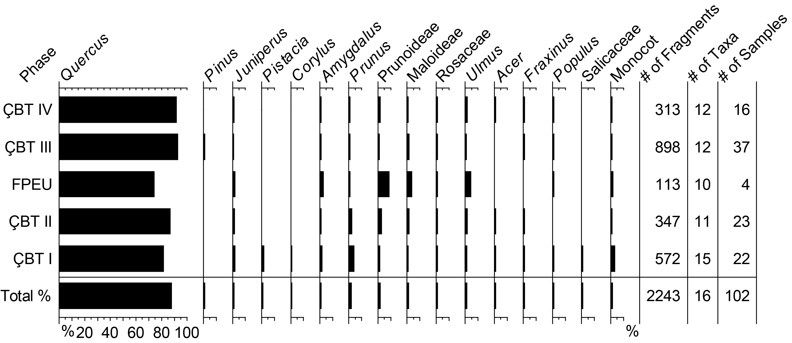

Figure 3. Anthracological diagram of percentage fragment counts of taxa identified at Çamlıbel Tarlası, excluding hardwood indeterminate and indeterminate charcoal, as well as the two samples from mixed phased deposits.

Scientific Name | Common Name | Count | Weight (g) | Ubiquity %
Gymnosperms | Softwoods/conifers
Juniperus | Juniper | 27 | 0.203 | 15.4%
Pinus | Pine | 1 | 0.008 | 1.0%
Coniferales | Conifer (indeterminate) | 3 | 0.003 | 2.9%
Angiosperm dicots | Hardwoods
Acer | Maple | 6 | 0.062 | 4.8%
Corylus | Hazel | 1 | 0.000 | 1.0%
Fraxinus | Ash | 8 | 0.100 | 5.8%
Pistacia | Pistachio | 9 | 0.525 | 1.0%
Quercus (deciduous) | Oak (deciduous) | 1337 | 14.959 | 86.5%
Quercus | Oak | 661 | 12.160 | 74.0%
Amygdalus | Almond | 20 | 0.393 | 12.5%
Prunus | Cherry and/or plum | 40 | 0.986 | 20.2%
Prunoideae | Amygdalus and/or Prunus | 43 | 1.628 | 27.9%
Maloideae | Rosaceae subfamily, includes apples, pears, hawthorns, and serviceberries | 26 | 0.229 | 17.3%
Rosaceae | Rose family | 16 | 0.137 | 9.6%
Populus | Poplar | 15 | 0.041 | 13.5%
Salicaceae | Poplar (Populus) and/or willow (Salix) | 1 | 0.016 | 1.0%
Ulmus | Elm | 31 | 0.358 | 19.2%
Indet. Hardwood | Angiosperm dicotyledon (indeterminate) | 343 | 3.739 | 80.8%
Other
Herbaceous Dicot | Non-woody dicotyledons | 3 | 0.019 | 2.9%
Monocot/Poaceae | Monocotyledon/grass | 37 | 0.168 | 21.2%
Bark | Bark (indeterminate) | 147 | 1.614 | 40.4%
Indeterminate | Indeterminate | 40 | 0.816 | 26.0%
 | Total | 2815 | 38.164 | 99.1%

Table 4. Fragment counts, weights, and ubiquity (expressed as a percentage) of plants identified in the anthracological record from Çamlıbel Tarlası, all phases combined.

4.1.1. Oaks (Quercus)
Approximately 71% of the 2815 analyzed charcoal fragments were identified as oak (Quercus) (Figure 3; Table 4). Oak wood shows very broad aggregate rays alternating with many uniseriate rays (Schweingruber, 1990a; Figure 4a-d). To distinguish deciduous and evergreen oak type with certainty it is ideal that an entire growth ring or, preferably, several growth rings are available for examination of the vessel arrangement pattern in both the early and the late wood. Only deciduous oak species are reported to grow in north central Anatolia, including Quercus cerris, Q. pubescens, and Q. macranthera subsp. syspirensis (Davis, 1982). It is not possible to distinguish between these species on the basis of wood anatomy (Schweingruber, 1990a).

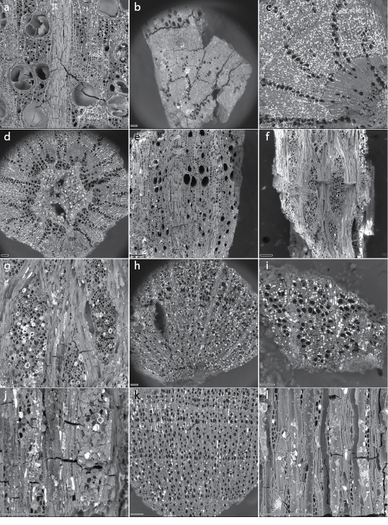

Figure 4. SEM images of oak and Rosaceae wood charcoal; magnifications vary, all scale bars 100 µm. a-d) Quercus: a) deciduous oak (specimen 310-4434-6), TS plane showing aggregate rays alternating with many uniseriate rays, distinct growth ring boundary, abrupt transition from early to late wood, and ring-porous vessel arrangement, with large early wood vessels containing tyloses; b-d) small diameter (CD3) juvenile oak charcoal (specimens 97-4390-5, 313-828-10, and 848-5524-2, respectively), TS planes showing semi-ring-porous to diffuse-porous vessel arrangement, gradual transition from early to late wood, no tyloses, no aggregate rays, pith in shape of star with five points. e-g) Amygdalus specimen 310-4448-2: e) TS plane showing wide rays, ring-porous vessel arrangement; f-g) TLS plane with 6- to ~12-seriate rays. h-j) Prunus specimen 843-4897-10: h-i) TS planes showing wide rays and diffuse-porous vessel arrangement; j) TLS plane showing 4- to 6-seriate rays. k-l) Maloideae specimen 647-4407-3: k) TS plane showing distinct growth ring boundaries, narrow rays, and diffuse-porous vessel arrangement; l) TLS plane showing 1- to 2-seriate rays. SEM images by Peter Kováčik.

Deciduous oaks exhibit ring-porous vessel arrangement, with large vessels in the early wood and a generally abrupt transition to smaller vessels in the late wood (Figure 4a); such specimens are classified as “Quercus (deciduous)” to express a high level of certainty. Large diameter branch or trunk wood exhibits the representative anatomical features necessary for distinguishing deciduous from evergreen oak, while juvenile wood from twigs and small branches does not. Differences between juvenile and mature wood anatomy, including oak species, are recognized by wood anatomists (Carlquist, 2001; Schweingruber, 1990b; Sousa et al., 2009; Zobel and Sprague, 1998).
About one fifth (22%, 434 fragments) of all oak charcoal fragments in this assemblage were assigned to curvature degree 3 (CD3) and is considered juvenile wood, originating from small branches or the inner portion of larger branches. Among CD3 fragments, 76% exhibit a semi-ring-porous to diffuse-porous vessel arrangement with a less abrupt transition between early and late wood (Figures 4b and 4c). In addition, 27% of these CD 3 fragments include pith and the vessel cavities of 78% of these fragments lack tyloses, which is characteristic of juvenile wood (Marguerie and Hunot, 2007; Schweingruber, 1990b; Wright, 2018). Aggregate rays are also typically absent in the xylem of twigs (Crivellaro and Schweingruber, 2013:316-324). Complete pith was observed in some specimens exhibiting the shape of a star with five points (Figure 4d). According to Schweingruber (1990a), this form is typical for Quercus, as well as Castanea and Robinia. These characteristics confirm the identification of these non-ring-porous specimens as juvenile wood, rather than mature evergreen oak.
In addition, 71% of all oak charcoal fragments exhibited an incomplete or a single growth ring. The ease with which one can assess the characteristics necessary to successfully distinguish deciduous and evergreen oaks increases with the number of growth rings, as these are more likely to include mature oak wood anatomy. Figure 5 indicates the relationship between certainty of identification (deciduous oak versus indeterminate oak) in this assemblage, and we indeed find a positive correlation between number of rings and certainty of identification. Thus, we conclude that the inability to assign all oak fragments to deciduous species is based on the immature and/or fragmentary state of many specimens, rather than on the presence of non-deciduous oaks in the assemblage. No definitively evergreen oak was identified among mature oak specimens. We thus assume that indeterminate oak specimens, both small fragments and juvenile oak fragments, represent one or more of the deciduous species native to north central Anatolia.

Figure 5. Oak taxon identification by number of growth rings present; “<1” includes both fragments without a clear complete growth ring and those too vitrified permit counting. Total fragment counts are given for each column.

4.1.2. Rose family (Rosaceae)
Several taxa within the rose family (Rosaceae) together comprise 5.2% of the analyzed charcoal assemblage from Çamlıbel Tarlası and are more numerous than any taxon other than oak. Rosaceae taxa identified include the subfamilies Maloideae (including pears, apples, hawthorns, serviceberries, and others) and Prunoideae (almonds, plums, cherries, peaches, apricots), as well as indeterminate Rosaceae that may represent taxa beyond those subfamilies. Within the Prunoideae, it is possible to distinguish the wood of Amygdalus (almonds) and Prunus (plums and cherries), following Asouti et al. (2018). The relative proportions of these taxa within the Rosaceae, by phase, are given in Figure 6.

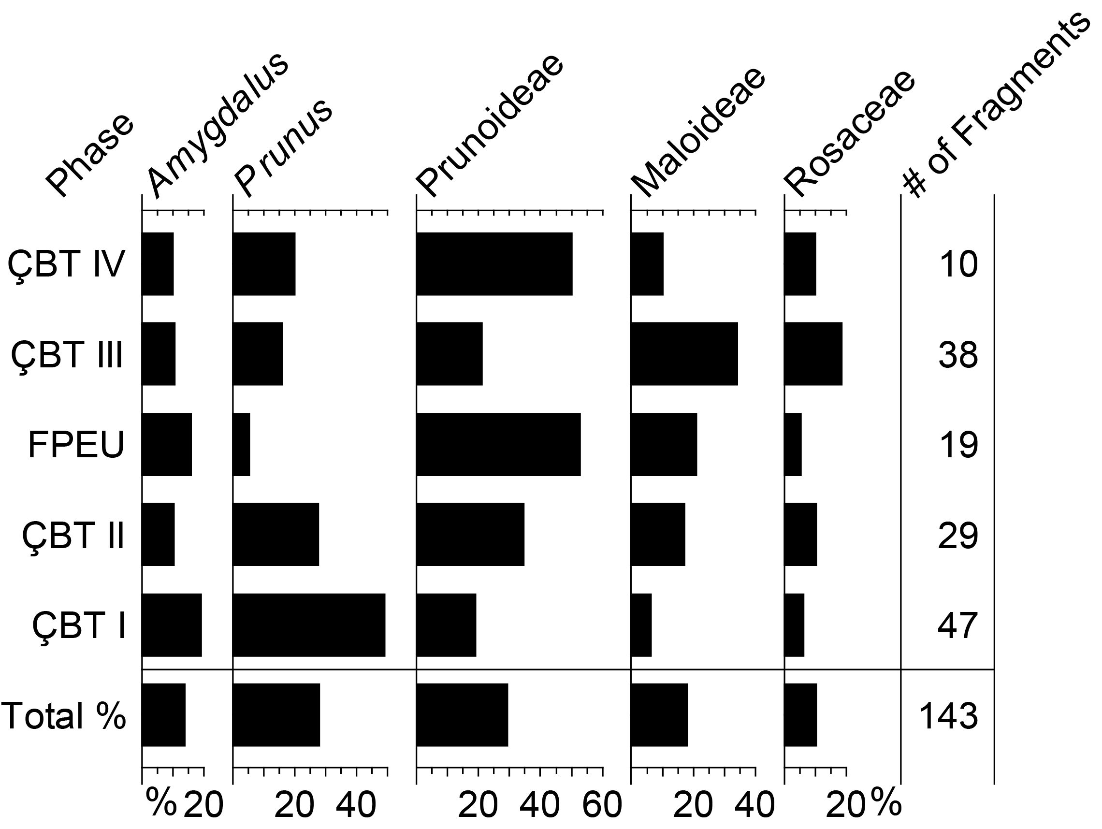

Figure 6. Anthracological diagram of identified taxa among all Rosaceae charcoal, by phase.

Charcoal fragments assigned to Rosaceae (16 fragments, 0.6% of all examined fragments) include pieces too small or too vitrified for further identification. Most abundant were Prunoideae (including both Amygdalus and Prunus) charcoal fragments (103 fragments, 3.7% of all fragments). To distinguish almonds from cherries and plums, we followed key characteristics described by Asouti et al. (2018:27), which include wood porosity (ring- vs diffuse-porous) and ray width. Both taxa were identified: almond (20 fragments, 0.7% of all fragments) and plum/cherry (40 fragments, 1.4%). Charcoal fragments labeled Prunoideae (43 fragments, 1.5% of all fragments) were too small or too vitrified for identification either as Amygdalus or Prunus.
Although all Amygdalus charcoal fragments from this project exhibit a ring-porous vessel arrangement, ray widths varied significantly. The majority of almond charcoal fragments included rays up to 6-8 seriate, while only two specimens had rays with a maximum width of 3-4 cells. In addition, extremely wide rays (~10 or more seriate) were noted in samples 257-112-27 (phase ÇBT I), 1007-5856-15 (ÇBT I), 315-446-2 (ÇBT II), and 310-4448-2 (ÇBT III; Figure 4e-g). Asouti et al. (2018) have associated variation in ray width with growth form: small diameter branches (narrow rays) vs. large diameter branches or trunk wood (wide rays). At least three wild species, A. webbii, A. orientalis, and A. graeca, as well as domesticated A. dulcis (syn. A. communis), grow in central Anatolia; the wild species are native and the domesticate may be native, but is at least widely naturalized through the region (Davis, 1972:22-27).
Charcoal fragments identified as Prunus exhibit a diffuse-porous arrangement of solitary vessels and vessels in short radial groups. Diffuse- to semi-ring-porosity and narrow rays are characteristic of cherry/plum wood (Asouti et al., 2018). A concentration of somewhat larger early wood vessels along the growth ring seems to be prevalent, although vessels further into the growth ring are more or less same size (Figures 4h and 4i). Rays are usually 1-6 seriate, although several specimens exhibited 8-, 10-, and 12-seriate rays. According to the Xylem Database (2010), some Prunus species, such as Prunus avium, can include rays up to 16-seriate. According to Davis (1972), P. spinosa, P. domestica, P. cerasifera (syn. P. divaricata), P. incana, and P. mahaleb can be found in the study area. It is not possible to distinguish between these species on the basis of wood anatomy (Asouti et al., 2018; Schweingruber, 1990a).
Maloideae specimens are less numerous than those of Prunoideae, totaling 26 fragments (0.9% of all charcoal). This subfamily may include species of Cotoneaster, Crataegus, Malus, Pyrus, Sorbus, or other native genera, which are indistinguishable on the basis of wood anatomy (Schweingruber, 1990a). Maloideae charcoal is diffuse to semi-ring porous with mostly solitary vessels and more or less distinct growth rings (Figure 4k and 4l). The majority of these fragments have 1- to 2-seriate rays, with 3-seriate rays rare.

4.1.3. Other dicotyledons
Pistacia charcoal (9 fragments, 0.3% of all charcoal) was present only in a single sample (254-2567; Figure 7a). Together with Quercus, Rosaceae, Prunoideae, Maloideae, and Juniperus, Pistacia represent a suite of species typical of central Anatolian open woodlands of the early Holocene, such as the Konya plain, where a Pistacia-Amygdalus-Maloideae savanna woodland has been reconstructed (Asouti and Kabukcu, 2014). Wild Pistacia species are, however, still found in north central Anatolia today (Davis, 1967:547-549).

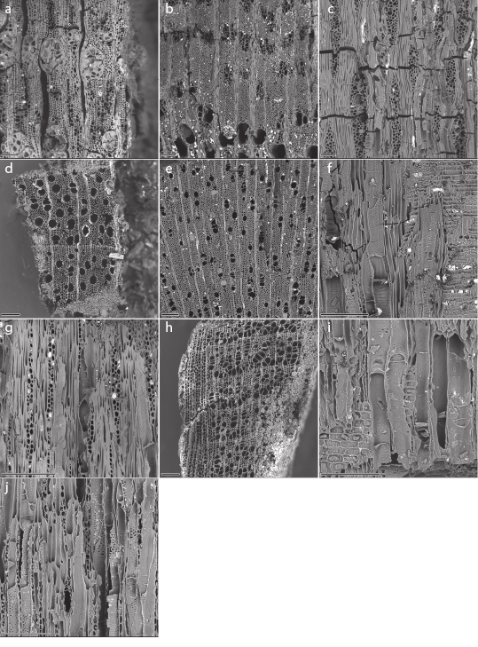

Figure 7. SEM images of less common dicotyledon wood charcoal; magnifications vary, all scale bars 100 µm. a) Pistacia (specimen 254-2567-1), TS plane showing large early vessels and pores/parenchyma groups in slightly oblique orientation. b-c) Ulmus specimen 1007-5858-25: b) TS plane showing ring-porous vessel arrangement, late wood vessels grouped in tangential and oblique bands; c) TLS plane showing homogeneous 1- to 6-seriate rays. d-g) Acer: d) TS plane showing diffuse-porous vessel arrangement, vessels solitary and in short radial files, thin- and thick-walled fibers in a patchy pattern, narrow rays (specimen 1009-5871-15); e) TS plane of small diameter wood (CD3; specimen 632-3880-1); f) RLS plane showing homogeneous rays, simple perforation plates, and spiral thickenings in vessels (specimen 632-3880-1); g) TLS plane showing homogeneous 1- to 3-seriate rays, simple perforation plates, and spiral thickenings in vessels (specimen 632-3880-1). h-j) Corylus specimen 257-1112-18: h) TS plane showing diffuse-porous vessel arrangement, pores in wide radial clusters, and aggregate rays; i) RLS plane showing homogeneous and heterogeneous rays, scalariform perforation plates, and fine spiral thickenings in vessels; j) TLS plane showing homogeneous and heterogeneous rays, scalariform perforation plates, and fine spiral thickenings in vessels. SEM images by Peter Kováčik.

Ulmus charcoal (31 fragments, 1.1% of all fragments) is exclusively from large-diameter wood (CD1; Figures 7b and 7c). Two species are present in this region of Turkey today (U. glabra and U. laevis); both are found in mixed woodlands and the latter also in riparian thickets (Davis, 1982). The wood of the two species cannot be distinguished. Two other taxa of mixed woodlands, maple (Acer: 6 fragments, 0.2% of all fragments; Figure 7d-g) and hazel (Corylus: 1 fragment; Figure 7h-j), are rare in the assemblage.
Wood from several riparian taxa also was used. Poplar (Populus) charcoal (15 fragments, 0.5% of all fragments) is diffuse porous with uniseriate homogeneous rays (Figure 8a-c). It was not possible to distinguish whether one Salicaceae fragment from phase ÇBT I (sample 1009-5871) is poplar or willow (Salix), which differ only in the presence of homogeneous (Populus) or heterogeneous (Salix) rays and the presence/absence of upright marginal ray cells visible in tangential and radial sections. Ash (Fraxinus), another riparian taxon, is less numerous (8 fragments, 0.3% of all fragments; Figure 8d-f).

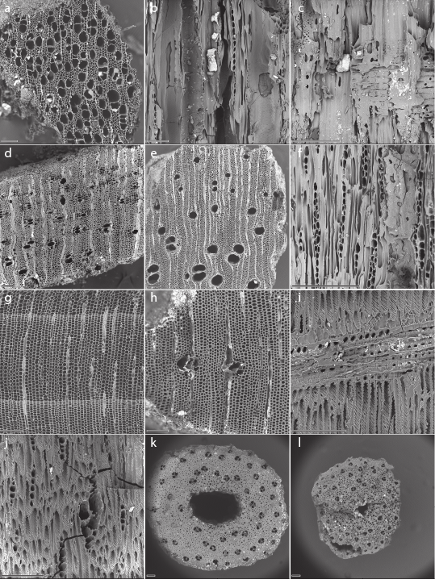

Figure 8. SEM images of riparian dicotyledon, conifer, and monocotyledon wood charcoal; magnifications vary, all scale bars 100 µm. a-c) Populus specimen 313-828-16: a) TS plane showing diffuse-porous vessel arrangement and narrow rays; b) RLS plane showing homogeneous rays; c) TLS plane showing homogeneous uniseriate rays. d-f) Fraxinus: d) TS plane showing thick-walled latewood vessels and vasicentric paratracheal parenchyma, narrow rays (subsample 647-4407-9); e) TS plane showing ring-porous vessel arrangement, thick-walled vessels with vasicentric paratracheal parenchyma, narrow rays (specimen 439-3546-4); f) TLS plane showing homogeneous 1-3-seriate rays, simple perforation plates in vessels (specimen 439-3546-4). g) Juniperus (specimen 887-5763-3) TS plane showing tracheids, distinct growth ring boundaries, and intercellular spaces. h-j) Pinus specimen 869-5633-4: h) TS plane showing traumatic resin canals and thick-walled rounded tracheids indicating compression wood; i) RLS plane showing dentate ray tracheids and fenestriform cross-field pitting; spiral grooves on tracheid walls indicate compression wood; j) TLS plane showing uniseriate rays and radial intercellular resin canals; spiral grooves on tracheid walls and “rugged” fusiform rays suggest compression wood. k-i) Monocot, likely Poaceae (grass), stem fragments in TS plane showing vascular bundle arrangement: k) specimen 843-4897-20; i) specimen 466-4111-6. SEM images by Peter Kováčik.

Three charred herbaceous dicot stem fragments (0.1% of all charcoal) exhibit vascular tissues in discrete bundles. These fragments are likely from non-woody annual or biennial dicotyledons. Hardwood indeterminate and indeterminate charcoal fragments were too small or too vitrified for further identification; these represent 12.2 and 1.4% of all examined charcoal, respectively. Also relatively abundant were bark fragments; these may represent woody angiosperms or gymnosperms, and comprise 5.2% of the examined charcoal fragments.

4.1.4. Conifers
Juniper (Juniperus) represents only 1% of all examined charcoal (27 fragments; Figure 8g) but is present in all phases. A single Pinus charcoal fragment (specimen 869-5633-4, ÇBT III) exhibits window-like cross-field pitting and dentate ray tracheids (Figure 8h-j). Two pine species, Pinus nigra subsp. pallasiana (black pine) and Pinus sylvestris (Scots pine/common pine), grow in central Anatolia (Davis, 1965) and exhibit window-like cross-field pitting and dentate ray tracheids (Schweingruber, 1990a). It is not possible to distinguish these species on basis of wood anatomy. In addition, thick-walled, round tracheids and traumatic vertical resin canals observed in transverse view (Figure 8h), spiral grooves (also called helical cavities; not thickening) in radial and tangential views (Figures 8i and 8j), and rugged fusiform rays in tangential section (Figure 8j) suggest that these represent compression wood, which develops on the lower part of inclined stems and branches of conifers (IAWA Committee, 2004:23, 30; Lee and Eom, 1988). Three conifer fragments (0.1% of all fragments) were too small for further identification.

4.1.5. Monocotyledons
A relatively large number (37 fragments, 1.3% of all fragments) of small diameter, hollow monocot stems were identified as probable grasses (Poaceae; Figures 8k and 8i). Based on the anatomical arrangement of vessels and diameter, we excluded reeds (Phragmites or Arundo), but were not able to identify the stems further. They are anatomically consistent with cereal stems, including wheat (Triticum spp.) in a modern comparative reference collection, but may instead represent wild grasses. Archaeobotanical analysis at this site also identified charred grass culms, likely from cereals (Stroud, 2016). Stroud (2016) identified intensive glume wheat processing was one of the primary activities performed at Çamlıbel Tarlası. It is possible that grass stems recovered in both macrofloral and charcoal samples represent discarded cereal straw, used directly as fuel or as animal bedding/fodder disposed of by burning.

4.2. Dendroanthracological analysis

The dendroanthracological data analyzed here are those based on curvature degree. Of the 2815 identified charcoal fragments, it was possible to record curvature degree for 2773 of them, including hardwood indeterminate and indeterminate (Table 5). We compared small diameter branch and inner wood (CD3) to large diameter branch and trunk wood (CD1) among all taxa identified in the Çamlıbel Tarlası charcoal assemblage, excluding indeterminate categories (Figure 9). This analysis indicates that the proportion of large diameter wood among each identified taxon is correlated to some extent with the general habit of the taxon: shrub or tree. Corylus, Amygdalus, and most Prunus species, as well as many other Rosaceae, grow as shrubs or small trees, as do evergreen Quercus species (Davis, 1972, 1982:662-681, 686-688); Juniperus, Maloideae, and Pistacia vary in size from shrubs and small trees to large trees (Davis, 1965:78-84, 1967:544-548, 1972); many deciduous Quercus species, as well as Ulmus, Populus, Fraxinus, Acer, and Pinus, are typically large trees (Davis, 1965:72-75, 1967:510-519, 1978:148-154, 1982:646-647, 662-681, 717-720). Those taxa that grow as large trees are generally represented by CD1 charcoal in the assemblage, while those that are more commonly small trees and shrubs are more often represented by CD3 charcoal. A few exceptions (e.g., Acer, a genus of large trees, is only 50% CD1 wood) may be an effect of small sample sizes (6 fragments, in the case of Acer).

Phase | CD 1 | CD 3 | Total Examined
ÇBT IV | 242 | 91 | 419
ÇBT III | 804 | 120 | 1029
FPEU | 88 | 31 | 132
ÇBT II | 218 | 158 | 485
ÇBT I | 299 | 282 | 708
Total | 1651 | 682 | 2773

Table 5. Curvature degree (CD1 and CD3; CD2 was identified for only one fragment) for all examined charcoal fragments, by phase; two samples from mixed-phase contexts are excluded. Note that “total examined” category includes examined fragments where CD determination was not possible.

Figure 9. Curvature degree (CD1 v. CD3) among charcoal fragments identified at least to family; the single fragment of Corylus charcoal was assigned CD2 and is not included here.

Additionally, we analyzed curvature degree across the five use phases at Çamlıbel Tarlası (Figure 10). In the earliest phase of occupation (ÇBT I), a slight majority (51%) of charcoal fragments originate from large diameter branch or trunk wood (CD1; Figure 10a). During the first phase of sustained occupation (ÇBT II), the proportion of CD1 wood increased slightly, to 58%. This increase continued into the first ephemeral use phase (FPEU), where 74% of fragments were assigned to CD1, and the second occupation phase (ÇBT III), when the use of CD1 wood reached its peak (87%). During ÇBT IV, the size of wood used changed, with a decline CD1 wood to 73% of analyzed fragments. This same pattern applies when examining only oak charcoal fragments (Figure 10b), which is not surprising given that oak comprises 79% of the total charcoal fragments with identifiable curvature, so oak drives the pattern seen in Figure 10a.

a.
b.
c.

Figure 10. Curvature degree (CD1 and CD3) of charcoal fragments across use phases: a) all taxa, b) Quercus only, c) all Rosaceae (including Amygdalus, Prunus, Prunoideae, Maloideae, and indeterminate Rosaceae).

However, when the same analysis is applied only to Rosaceae charcoal fragments (including Rosaceae, Maloideae, Prunoideae, Amygdalus, and Prunus, which together comprise 6% of fragments with identified curvature), proportions of CD1 to CD3 wood changes significantly (Figure 10c). Small diameter wood (CD3) comprises the majority of the assemblage in every phase, as also indicated in Figure 9; as suggested above, this is likely due to members of the rose family typically being shrubs and small trees. The use of large diameter branch and trunk wood (CD1) does, however, increase from ÇBT I through ÇBT III, just as among oaks. Similarly, this trend reverses in ÇBT IV, when the use of CD1 wood declines. Notably, analysis of the remaining taxa (which comprise 4% of wood fragments with recorded curvatures) is not informative, as five of these taxa (Populus, Ulmus, Pistacia, Pinus, Salicaceae) include only CD1 wood, and the remaining taxa together total only nine fragments of CD3 across the entire history of site use.

4.3. Contextual and spatial analyses

4.3.1. Analysis by context
Several types of contexts were sampled at Çamlıbel Tarlası, including features (a pit, a hearth, ovens, granaries), floors (exterior and interior) and ashy deposits that accumulated during use of those floors (top floor deposits, or TFDs), and a series of ash layers that define phase ÇBT I. The number of charcoal fragments in each of these context types are presented by phase in Table 6. Importantly, some context types were sampled in several phases (especially floors), while others are singular features that were found only in a single phase: most notable the ash layers of ÇBT I (Figure 2) and the well-defined hearth, granaries, and ovens within and adjacent to buildings S25, S28, and S29 of ÇBT II (Figure 11). Approximately two thirds of charcoal fragments analyzed originate from floor deposits (61%) and the deposits immediately overlying floors (6%); the ÇBT I ash layers provide most of the remaining charcoal fragments (26%).

Phase | Ash layer | Granary | Hearth | Oven | Pit | Exterior floor | Interior floor | Exterior TFD | Interior TFD | Deposit | Total
ÇBT IV |  |  |  |  | 41 | 315 |  | 58 | 5 |  | 419
ÇBT III |  |  |  |  |  | 153 | 816 | 60 |  |  | 1029
FPEU |  |  |  |  |  | 132 |  |  |  |  | 132
ÇBT II |  | 84 | 41 | 4 |  | 23 | 251 |  | 40 | 42 | 485
ÇBT I | 708 |  |  |  |  |  |  |  |  |  | 708
Total | 708 | 84 | 41 | 4 | 41 | 623 | 1067 | 118 | 45 | 42 | 2773

Table 6. Number of charcoal fragments by context type and phase (“TFD” = top floor deposit, a deposit that accumulated during use of a floor; “deposit” = uncertain depositional context).

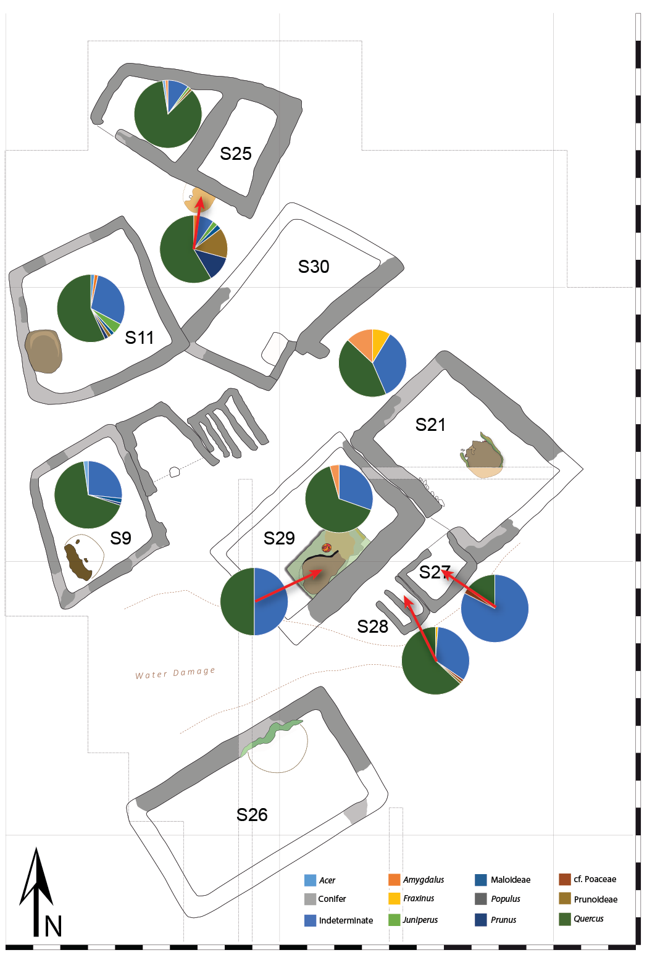

Figure 11. Wood charcoal proportions from ÇBT II phase buildings and associated features.

Among these contexts, there is some indication that different wood types may have been selected for different combustion episodes. While oak is the majority of every context type with more than two fragments present, and small sample sizes surely account for some of the apparent variation among contexts, a few context types are comprised of a larger-than-average proportion of non-oak wood (Table 7). Additionally, some taxa appear only in a few context types. The ÇBT I ash layers include every identified taxon in the assemblage, save pine, including the only hazel and pistachio from the charcoal record, as well as the majority of maple, Prunus, and Poaceae specimens. More than 10% of the identified charcoal this context is non-oak, non-Rosaceae taxa, the largest proportion of minor taxa in a contextual assemblage with more than 10 fragments identified.
The floors, dating to the subsequent occupation phases, show an interesting distinction in composition between interior and exterior surfaces. Interior floors have a much greater proportion of oak than exterior floors (94% v. 85%), while the latter contain more fragments of minor taxa, especially elm and juniper, as well as the Prunoideae. Since floors typically contain secondary charcoal deposition, of greater interest are the hearth and ovens of phase ÇBT II (Figure 11), which might contain primary deposits of deliberately burned charcoal. Alas, the two ovens were quite clean of charcoal, with only four charcoal fragments in one (in S29) and the other devoid of identifiable charcoal; these ovens did, however, contain ~1000 charred wild seeds, as well as crop seeds: several glume wheats, barley, lentil, bitter vetch, and flax (Stroud, 2016). The hearth, attached to the exterior of the south wall of building S25, contains a variety of Rosaceae taxa (34% of all identified fragments), in addition to oak (63%) and a single juniper fragment; these data suggest that Prunoideae may have been a deliberate choice of fuel for combustion in this hearth. In contrast, internal and external floor deposits, as well as the granary deposit (in building S28), of phase ÇBT II resemble the greater pattern of floor deposits, with an abundance of oak and indeterminate charcoal.

Taxon | Ash layer | Granary | Hearth | Oven | Pit | Exterior floor | Interior floor | Exterior TFD | Interior TFD | Fill | Deposit | Total
Gymnosperms
Juniperus | 10 |  | 1 |  |  | 10 | 4 |  |  |  | 2 | 27
Pinus |  |  |  |  |  |  | 1 |  |  |  |  | 1
Coniferales | 1 |  |  |  |  | 1 |  |  |  |  | 1 | 3
Angiosperm Dicots
Acer | 4 |  |  |  |  |  | 1 | 1 |  |  |  | 6
Corylus | 1 |  |  |  |  |  |  |  |  |  |  | 1
Fraxinus | 3 | 1 |  |  | 1 | 2 | 1 |  |  |  |  | 8
Pistacia | 9 |  |  |  |  |  |  |  |  |  |  | 9
Quercus | 466 | 53 | 24 | 2 | 32 | 423 | 851 | 80 | 7 | 1 | 59 | 1998
Amygdalus | 9 |  | 1 |  |  | 7 | 2 |  |  |  | 1 | 20
Prunus | 23 |  | 5 |  |  | 4 | 7 |  |  |  | 1 | 40
Prunoideae | 9 | 1 | 6 |  | 1 | 15 | 9 |  |  |  | 2 | 43
Maloideae | 3 |  | 1 |  | 1 | 7 | 13 |  |  |  | 1 | 26
Rosaceae | 3 |  |  |  |  | 2 | 7 | 3 |  |  | 1 | 16
Populus | 4 |  |  |  | 1 | 5 | 4 |  | 1 |  |  | 15
Salicaceae | 1 |  |  |  |  |  |  |  |  |  |  | 1
Ulmus | 8 |  |  |  |  | 16 | 5 | 1 |  |  | 1 | 31
Indet. Hardwood | 87 | 23 | 2 | 2 | 4 | 85 | 98 | 19 | 14 |  | 9 | 343
Other
Herbaceous Dicot |  |  |  |  |  | 1 | 1 |  |  |  | 1 | 3
Monocot/  Poaceae | 19 | 1 |  |  |  | 8 | 5 | 2 | 1 | 1 |  | 37
Bark | 34 | 4 | 1 |  | 1 | 27 | 47 | 10 | 21 |  | 2 | 147
Indeterminate | 14 | 1 |  |  |  | 10 | 11 | 2 | 1 |  | 1 | 40
Total | 708 | 84 | 41 | 4 | 41 | 623 | 1067 | 118 | 45 | 2 | 82 | 2815
% Quercus of identified | 81.5% | 94.6% | 63.2% | 100% | 88.9% | 84.8% | 93.5% | 92.0% | 77.8% | 50% | 86.8% | 87.7%
% Rosaceae (all) of identified | 8.2% | 1.8% | 34.2% | 0% | 5.6% | 7.0% | 4.2% | 3.4% | 0.0% | 0% | 8.8% | 6.4%
% other identified | 10.3% | 3.6% | 2.6% | 0% | 5.6% | 8.2% | 2.3% | 4.6% | 22.2% | 50% | 4.4% | 6.0%

Table 7. Charcoal fragment counts by taxon and context type, all phases grouped. Percentages at the bottom calculated out of total fragments identified to at least the family level.

4.3.2. Spatial analysis

The majority of charcoal in the Çamlıbel Tarlası assemblage was collected from floor deposits and ashy deposits that accumulated during use of these floors (top floor deposits, or TFDs). These floors, whether interior or exterior, were collected in gridded meter squares and so can be mapped spatially to identify differences in wood charcoal deposit patterns within and outside specific structures. While Stroud (2016) used this approach to great effect in identifying differential distribution of seeds across different activity spaces at Çamlıbel Tarlası, this method was less effective in identifying meaningful patterns among the wood charcoal assemblage. Since the large majority of the charcoal assemblage sitewide consists of oak, followed by indeterminate fragments (including bark and indeterminate hardwood), spatial patterning tends to indicate relative homogeneity of charcoal assemblages over space. This was noted in the analysis above of the floors and features of phase ÇBT II (Figure 11), in which floors are similarly dominated by oak and indeterminate charcoal, as are the deposits in the oven and granary, which suggests that those may be secondary deposits similar in origin to floor deposits. The one distinct sample, from the hearth attached to building S25, indicates additional use of Prunoideae.
In another example of an area where spatial analysis was useful, five successive floors were excavated within a single structure, the phase ÇBT III building S3, termed the “Burnt House” during excavation. Three of these floors can be productively compared: Floors A (the first, and lowest), C (the third), and D (the fourth) (Figure 12). The lowest floor was a well-plastered lime surface that contained a considerable density of unidentifiable charcoal, mainly small fragments with less than one growth ring preserved. The northeastern most sample, however, includes monocot charcoal, as well as Prunus and elm, in addition to oak (Figure 12a). In contrast, charcoal from atop Floor C, which is a less-well-plastered surface, is nearly exclusively oak, with only a single monocot fragment among the 158 examined specimens from this surface (Figure 12b). The Floor D above that layer, also a lower-quality lime-plastered surface, is also nearly homogenously oak, although with a few fragments of poplar, Maloideae, and Prunoideae scattered among the samples (Figure 12c). In no case, however, is a clear spatial pattern of differential wood use evident, which is not entirely surprising considering that floor deposits are typically secondary and divorced from their original context of combustion. Another possibility, especially for the small fragments of Floor A, is that this charcoal was produced, at least in part, during the lime preparation process, and introduced to the floors during plastering at the time of initial construction.

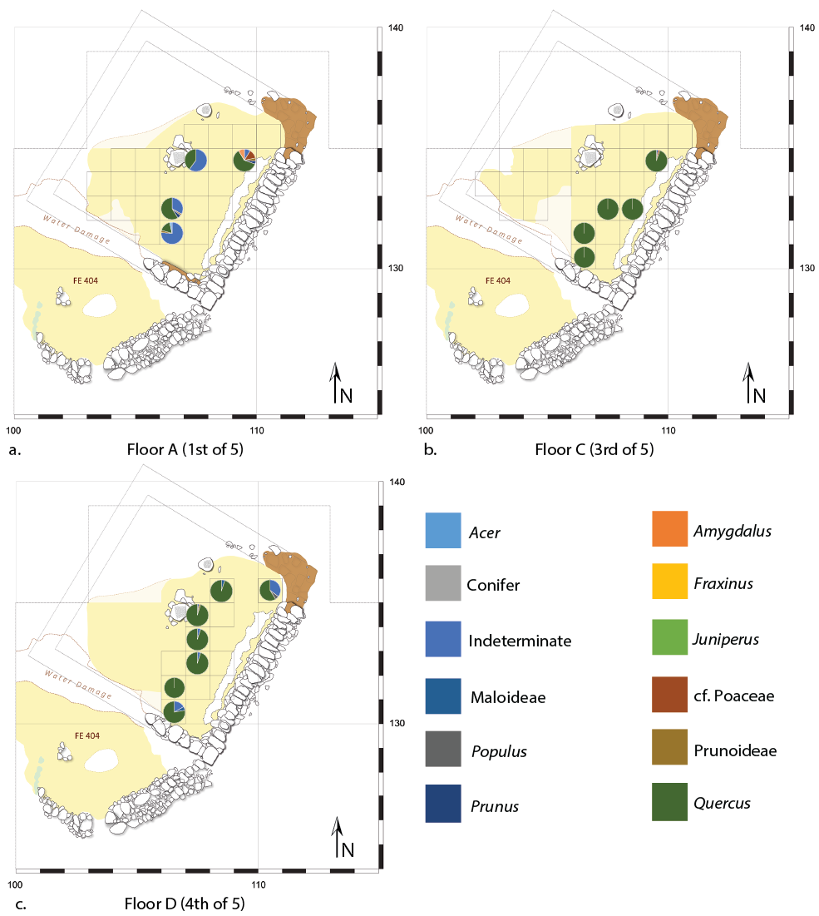

Figure 12. Wood charcoal proportions from Floors A, C, and D of Structure 3, phase ÇBT III. Grid is 1-m-square sampling grid.

5. Discussion

5.1. Woodland reconstruction

Deciduous oak dominates the wood charcoal assemblage of Çamlıbel Tarlası during all phases of occupation. We infer this to have been the main fuel source during the use life of the site, given that there are no taphonomic factors that appear to bias the assemblage (Théry-Parisot et al., 2010). According to the “Principle of Least Effort” (Shackleton and Prins, 1992), charcoal assemblages that accumulated as the result of long-term, routine use of wood as fuel should mirror local woodland composition, absent other constraining variables. However, as has been noted on numerous occasions (e.g., Asouti and Austin, 2005; Marston, 2009; Shackleton and Prins, 1992), the Principle of Least Effort does not apply universally, and a variety of models help to explain both when selection of woody plants occurs and which species are likely to be preferentially selected or ignored during wood gathering. Several ethnographic cases (e.g., Henry and Théry-Parisot, 2014) make evident that characteristics that make pieces of wood desirable for combustion may be related more to the state of the wood (dry, rotted, size, etc.) rather than the taxon to which it belongs. As a result, we are left with two possibilities: that deciduous oak dominated the Chalcolithic landscape of Çamlıbel Tarlası, or that deciduous oak was simply a component of local woodlands that was preferentially selected for fuel use. It is possible to distinguish between these possibilities by considering the modern woodland ecology of the region, studying the specific depositional context of samples, and considering alternative harvesting models for fuel (e.g., Dufraisse, 2008), to determine the likely frequency of oaks in the original landscape of the site.
If we begin with the hypothesis, following the Principle of Least Effort, that the overwhelming presence of deciduous oak fragments is the product of an oak woodland that dominated the landscape of Çamlıbel Tarlası during all periods of site use, we can consider the ecological plausibility of such a vegetation community. While it is not possible to distinguish deciduous oak species based on wood anatomy within this region, the 20th century distribution of oak species in the area indicates that at least three oak species may have contributed to the archaeological assemblage: Quercus cerris, Q. pubescens, and Q. macranthera subsp. syspirensis (Davis, 1982). These species present three distinct growth habits: from a low shrub (Q. pubescens) to small trees (Q. macranthera subsp. syspirensis) to large trees (Q. cerris). While both Q. pubescens and Q. macranthera subsp. syspirensis favor open steppe and scrubland habitats (Davis, 1982:666, 672), Q. cerris can form dense canopy forests, in association with other tree taxa or as monospecific stands (Davis, 1982:674). Although geoarchaeological data indicate widespread forest clearance of the immediate vicinity of Çamlıbel Tarlası prior to the modern period (Marsh, 2010), resulting in the presently denuded and heavily incised landscape (Figure 13), in other areas of northern Anatolia dense canopy forests dominated by Q. cerris have been common up to the present day (Atalay, 1997; Marston, 2017; Zohary, 1973). Thus, we find strong contemporary ecological evidence that dense oak forest is an ecologically plausible woodland community in the vicinity of the site (e.g., Zohary, 1973), and geoarchaeological investigations support a narrative of woodland clearance from the time of the first use of Çamlıbel Tarlası, and continuing post-occupation. These parallels indicate that a dense, oak-dominated canopy forest is a plausible ecological community in the vicinity of Çamlıbel Tarlası during the Chalcolithic period.

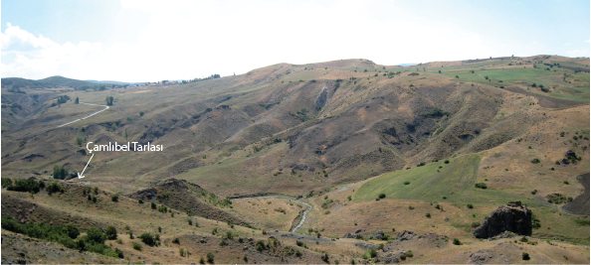

Figure 13. Present landscape of Çamlıbel Tarlası with few, scattered trees. Note deep erosional gullies on the far slope, with incisions following bedrock structure, which postdate use of the site. Photograph by Ben Marsh.

The alternative possibility is that oak formed only a smaller component of a more diverse woody vegetation but was preferentially collected and used for fuel. Shackleton and Prins (1992) highlight two scenarios in which such selection is expected to arise: 1) conditions of abundance, as in “the typical situation encountered at a new settlement in a relatively unexploited area” (Shackleton and Prins, 1992:633), and 2) conditions of scarcity of dry wood, but abundance of living green wood, such that there is a diversity of woody taxa available for use. The first of these scenarios seems likely to have applied at the time when Çamlıbel Tarlası was settled, although whether selection occurred under these conditions of abundance is still unclear: preferential use of a very common taxon may look very similar to indiscriminate use of that taxon in proportion to its abundance. If oak were a poor-quality fuel, or provided other economic uses such that it was preferentially ignored when harvesting wood (e.g., for construction [Dufraisse, 2008] or fruit [Gallagher, 2014]), then we might expect a disparity between landscape frequency and use frequency. In this case, however, where fuel was in demand for both metallurgy (all phases) and domestic uses (phases ÇBT II-IV), and given the high fuel value of oak (Marston, 2009), these two scenarios are equally plausible—oak was likely at least very common, if not dominant, in the landscape at the time of settlement.
Charcoal fragments from non-oak woody taxa represent less than 9% of the assemblage (11% of all wood identified at least to family). The other primary taxa included in the assemblage, those in the Rosaceae (5% of the assemblage, mainly Prunoideae: cherry or plum, and almond) favor open habitats, suggesting that an open woodland community was present during the occupation of Çamlıbel Tarlası. Such a community may have included oaks, especially Q. pubescens, but was likely distinct from a putative canopy forest dominated by Q. cerris. Of the remaining taxa identified, juniper (Juniperus) and pistachio (Pistacia) are also often members of open woodland communities (Davis, 1965, 1967:547-549). Maple (Acer), elm (Ulmus), and hazel (Corylus) are found in mixed deciduous forests, although elm can also be found in riparian communities and as stand-alone trees in open woodlands (Davis, 1967:510-519, 1982:646-648, 686-687). Poplar (Populus) and ash (Fraxinus) charcoal fragments indicate presence of riparian vegetation (Davis, 1978, 1982) along the Karakeçili Deresi, which flows next to the site, or within the much larger nearby Budaközü valley. Although riparian species represent minor (1% of all charcoal) taxa in this assemblage, they confirm that the present-day Karakeçili Deresi stream existed at the time of first occupation, a reconstruction compatible with regional hydrogeological study (Marsh, 2010; Schoop, 2015). The near-lack of pine (only one fragment) suggests a lack of access to, or need to access, higher-elevation forests in which pine is a dominant taxon (Davis, 1965; Zohary, 1973).
We can thus reconstruct two alternative landscapes at the time of first use of Çamlıbel Tarlası. The first consists of three woodland communities: 1) canopy forest dominated by oak (Q. cerris, most likely) with maple, hazel, elm, and potentially poplar as minor components; 2) open woodland with an abundance of Rosaceae, as well as juniper (likely both J. oxycedrus and J. excelsa), pistachio, and possibly elm; 3) riparian thickets with ash, possible willow, and poplar along the Karakeçili Deresi. The second plausible reconstruction involves two woodlands: a mixed woodland of varying density but relatively open, with oaks (likely Q. pubescens and Q. macranthera) the most common tree but all other taxa listed above included in the diverse woodland, and a riparian thicket as described above. Based on the large size of the oak wood burned on site, as indicated by curvature degree analysis (Figures 9 and 10), large trees, such as those found in a canopy forest, were available to the site’s inhabitants. This, together with the abundance of oak wood in the assemblage, suggests that the first woodland reconstruction, in which an oak-dominated canopy forest is the major woodland formation locally, is more likely accurate.
Pollen from paleoenvironmental cores taken in lakes and wetlands is often a valuable comparative source of evidence for reconstructing past woodland composition. A local pollen core does exist, from the site of Sülük Gölü near Hattusa, but it extends only into the first millennium BCE and no data have yet been published from the core (Dörfler et al., 2000). More useful are small assemblages of charcoal data from mid-first millennium BCE deposits at Hattusa and Kerkenes, the former only a few km east of Çamlıbel Tarlası and the latter 50 km southeast (Dörfler et al., 2000:377). Both consist of 35-40% deciduous oak and the remainder pine and juniper, roughly similar to Late Bronze and Iron Age charcoal from Gordion (Marston, 2017:77), where those three genera dominate the assemblage in comparable proportions. The utilization of pine and juniper, which grow further from Gordion than oak, was interpreted there as a consequence of the need to roof large buildings (Marston, 2009). Similar construction demands are likely for the large urban centers of Hattusa and Kerkenes. The near exclusion of these softwood taxa at Çamlıbel Tarlası reflects different wood needs for construction, as well as the likely greater local abundance of oak woodland for fuel.

5.2. Wood harvesting practices

Wood was used at Çamlıbel Tarlası both for domestic fuel and for metallurgy, which preceded settlement of the site and local agricultural activity (Pickard et al., 2017; Schoop, 2015; Stroud, 2016). That fuel was primarily wood, rather than animal dung, as documented by this study and the archaeobotanical investigation of Stroud (2016). This wood was procured through fuel gathering, likely of initially locally abundant dry wood in phase ÇBT I, while in later phases wood appears to have been acquired through felling of trees. This may have been a response to declines in local fuel availability, but is also a result of woodland clearance to create arable land for farming and grazing. The frequent presence (21% ubiquity) of charred monocot stems, likely grasses and quite likely cereal stems, represents probable discard from cereal processing at the site, which is amply evident given the large number of hulled wheat rachis fragments present in the flotation assemblage (Papadopoulou and Bogaard, 2012; Stroud, 2016). This straw may have been used directly in fires as kindling, or used as flooring or animal bedding that was routinely discarded via fire.
Zooarchaeological analysis indicates that domesticated species at Çamlıbel Tarlası were dominated by cattle and pig, although sheep and goat were also common, together roughly 23% of all animal bones by NISP count (Pickard et al., 2016). The frequency of cattle, and to a lesser extent sheep and goats, indicates that the surrounding landscape was grazed, which can favor the spread of open oak woodlands (which may contain other taxa suited to such habitats, including those in the Rosaceae) rather than grassland steppe, as documented in the plains of southern Central Anatolia (Asouti and Kabukcu, 2014). As a result, agriculture may have both promoted scrub oak growth and led to the felling of large oak trees to clear fields, both contributing to the availability of oak for fuel use.
Curvature degree analysis for the most common wood taxa (oak and Rosaceae; Figure 10) indicates a sustained diachronic trend in the diameter of wood burned on site. Although large-diameter wood (CD1) is dominant among the oak charcoal assemblage during all phases, while rosaceous species are primarily represented by small-diameter wood (CD3), the use of large-diameter wood in both taxa gradually increased from ÇBT I to ÇBT III. Both taxa indicate a reversal during the final use phase (ÇBT IV), when use of large-diameter wood declined in frequency, though still remained higher than phases ÇBT I and II. The appearance and widespread presence of crucible fragments and slag suggest change in and possible intensification of metallurgical activity during ÇBT III, which would have increased demand for high-quality fuel wood, perhaps first processed into charcoal, for high-heat applications (Schoop, 2015:63-64). Other high-heat technologies employed at the site include the production of talc beads and lime (Schoop, 2015:64). It is possible that in order to intensify these activities, site occupants had to change their fuel acquisition strategies in order to gather more and/or higher-quality wood, resulting in the increased cutting and collection of large-diameter branch and trunk wood, especially under conditions of declining local wood availability due to prior harvesting activities. In ÇBT IV, maintaining a stable wood supply to support industrial production at the site may have necessitated additional woodland management systems to make local wood sources more sustainable. This could be accomplished by reducing harvest of whole trees and intensifying management techniques, such as coppicing and pollarding, in which trees produce greater biomass over long periods of time by maintaining a large, healthy root system (Altman et al., 2013; Halstead, 1998). While there is no direct evidence that coppicing was applied at Çamlıbel Tarlası, future tree-ring-width analysis may make such a determination possible (Deforce and Haneca, 2015; Out et al., 2018; Wright, 2018); such a study would focus on difference in oak ring-width diameters between phases ÇBT III and IV.
Curvature degree analysis indicates that approximately 25% of all charcoal originated from small-diameter wood (CD3; Table 5). A higher proportion of such wood was generally observed among taxa with smaller growth forms (i.e., small trees and shrubs), including rosaceous taxa and hazel (Figure 9). In contrast, elm, poplar, pistachio, and juniper are nearly exclusively represented by large-diameter wood. As elm and poplar are tall trees, as are some pistachios and junipers, it appears that the pattern of curvature degree matching the growth habit of wood taxa is also supported by these taxa. Interestingly, this suggests that tall junipers (e.g., Juniperus excelsa) were likely the source of (most, if not all) juniper wood used at the site, rather than scrub juniper (e.g., J. oxycedrus), which is found in open landscapes often also dominated by scrub oak (Davis, 1965:80).
The earliest phase of site use, ÇBT I, is distinct from later phases in several ways: it precedes permanent settlement of the site, the anthracological assemblage includes the highest proportion of small-diameter wood in the site’s sequence, the assemblage is the most diverse of all phases (including the only instance of hazel and pistachio in the sequence), and this period likely represents the first human intervention into local woodlands for large-scale fuel use. We suggest the high frequency of small-diameter wood during this period is representative of collection of locally abundant dry wood from forests with no legacy of fuel exploitation. A least-effort harvesting strategy of high-quality dry wood means that the anthracological assemblage reflects the availability of dry wood in the landscape, and thus as the majority of fuel was oak, we infer that this mirrors its dominance in the landscape. As settlement began (ÇBT II) and metallurgy intensified (ÇBT III), there was both increased access to large-diameter wood from trees felled to clear space for agricultural activities and increased demand for fuel, specifically high-heat-value fuel for smelting. Large-diameter wood is typically preferred for charcoal burning (e.g., Ludemann, 2010), which may have supplied smelt fuel. The step back towards smaller-diameter wood during ÇBT IV may be due to reduced availability of large trees in the fuel catchment of the site, a result of earlier wood harvesting practices, and potentially represents an effort towards more sustainable wood harvesting strategies, such as pollarding or coppicing, instituted to mitigate the ongoing loss of forest.

5.3. Wood use and deposition

That the large majority of the assemblage consists of oak (71% of all fragment examined) and unidentifiable wood (19%, including indeterminate hardwood) complicates efforts to identify patterns, both diachronic and spatial, in the use and deposition of wood at Çamlıbel Tarlası. The remaining 10% of the assemblage is divided nearly evenly between Rosaceae and non-Rosaceae taxa, totaling a minimum of 12 distinct taxa. As more than half of samples contained fewer than 40 fragments of charcoal, the number of fragments identified to one of the minor taxa is small for any individual sample, so spatial comparison is confounded by taxa being represented usually by a single fragment per sample. As a result, it is difficult to establish which apparent patterns are robust enough to warrant comparison and discussion.
There is no evidence for diachronic difference in taxon use (Figure 3). The only phase that appears distinct in taxon composition is FPEU, although that phase also has the lowest number of fragments examined (113), which suggests that the apparent difference may be an effect of small sample size rather than a real trend (towards slightly less oak, and slightly more Prunoideae). Some taxa do appear only in a single phase: hazel and pistachio (and indeterminate Salicaceae) are found only in ÇBT I, and pine only in ÇBT III. Three of these taxa are only represented by single fragments, however, and the nine pistachio fragments from phase CBT I all were found in a single sample (254-2567) and so may represent fragmentation of a single piece of wood. The only strongly supported diachronic trend is the sustained increase in the proportion of CD3 among both oak and Rosaceae between ÇBT I and III.
Spatial analysis of floor and top-floor deposits taken in a grid of square-meter units from the occupation phases (ÇBT I, II, III) had limited utility. The dominance of oak and unidentifiable wood fragments reduce visibility on possible changes in the diversity of wood that might be tied to use context, as seen in phase ÇBT II (Figure 11). The example of successive floors within ÇBT III (Figure 12), however, is one of the only cases where a clear distinction among floors is evident. The higher proportions of unidentifiable wood in the earliest surface deposits (Floor A) is due primarily to the presence of smaller fragments in that surface compared with those above. This may indicate longer use of this floor surface, which resulted in increased trampling and fragmentation of charcoal in comparison to later surfaces; alternatively, these small fragments may be inclusions in the lime plaster surface, byproducts of its production process. The data may equally indicate that Floor A was cleaned more frequently or extensively prior to reflooring compared to successive floors, which were “dirtier” (with larger charcoal fragments embedded) when they were taken out of use.
Comparing charcoal samples across context types is more informative, as there are some differences among specific types of features (Table 7). One interesting pattern is that interior floors have a higher proportion of oak (94% of identified fragments, 80% of all fragments examined) than exterior floor deposits (85% of identified, 68% of examined). Exterior floors also included a higher proportion of unidentifiable wood (20% of all fragments examined, v. 15% for interior floors). Exterior floors contain a higher proportion of Rosaceae (5.6% of all fragments examined, v. 3.6% for interior) and other minor taxa (6.7% of all fragments examined, v. 2.0% for interior). Because scattered floor deposits are heterogenous accumulations of secondary deposits, a specific reason for this distinction cannot be directly determined. One possible explanation, however, is that fuel used within structures, e.g., for small cooking or heating fires, was preferentially oak, and a wider variety of fuels were used for the broader array of activities practiced outside. Only in phase ÇBT II were interior ovens a regular feature within domestic structures (Schoop, 2015). Sadly, the two samples from two ÇBT II interior ovens are nearly devoid of charcoal, with only two oak and two indeterminate fragments in the oven of building S29 (Figure 11). Although this fits the pattern of oak used within buildings, these data are not robust enough to provide direct support for the hypothesis. In contrast, the exterior hearth attached to building S25, also dating to ÇBT II (Figure 11), includes at least three Rosaceae taxa (Amygdalus, Prunus, Maloideae, as well as indeterminate Prunoideae) which together total 34% of the identified fragments in that sample, with oak comprising almost all of the remainder. Again, this suggests a greater diversity of fuels were used in outdoor contexts, but also is only a single feature.
The remaining features include a large pit within the central courtyard of phase ÇBT IV (Schoop, 2009:Figure 54) and a two-bin constructed granary dating to ÇBT II (S28 in Figure 11; Schoop, 2015:52, 56). These samples are primarily comprised of oak, with only single fragments of Rosaceae, ash, poplar, and grass stem. Since their contents are likely secondary deposits that accumulated after the features went out of use, it is no surprise that these samples mirror the broader pattern of the overall charcoal assemblage.

6. Conclusions

The wood charcoal data from Çamlıbel Tarlası represent our first archaeological glimpse of wood harvest practices during the Late Chalcolithic of north central Anatolia and permit a reconstruction of local woodland community composition at that time. Our results suggest that an oak-dominated canopy forest was likely the primary woodland community in the region at the time of settlement, alongside an open mixed woodland and riparian thicket. As modern woody vegetation in the vicinity of the site is sparse, our woodland reconstruction accords with prior geomorphological study (Marsh, 2010) that indicates significant changes in the landscape that are the legacy of past human actions. Marsh (2010:81) argues that removal of vegetation is the first phase of the erosional sequence noted at Çamlıbel Tarlası and many other locations throughout central Anatolia (e.g., Marsh and Kealhofer, 2014), and that this transition begins shortly following the arrival of humans and their accompanying agricultural practices to a region. Certainly, the harvest of large-diameter wood implies the removal of mature trees, quite possibly related to regional agricultural development during phase ÇBT II, and potentially exacerbated by fuel needs for expanded metallurgical practices during ÇBT III (Schoop, 2011, 2015).
The question of whether wood use at Çamlıbel Tarlası mirrored the ecological availability of woody taxa or includes substantial human selection of wood for specific purposes remains open. There is evidence that oak, the primary fuel source, was also the dominant tree in the landscape. Spatial and contextual analysis, however, suggest that there may have been some selection of fuel: in particular, the greater abundance of oak within structures compared to exterior deposits indicates that oak may have been preferentially selected for the limited array of fuel uses in interior settings. The increase in the frequency of large-diameter wood in later periods, especially ÇBT III, may indicate a shift in the way that fuel wood was harvested due to changing fuel needs. One possibility is that wood was harvested for charcoal production, intended for high-heat smelting, which necessitated larger diameter wood. There is no direct evidence, however, of on-site charcoal production.
A challenge in the interpretation of results from Çamlıbel Tarlası is that there is a complete lack of comparative anthracological data from this time period within the region of the site, with the only other published Chalcolithic assemblage coming from southwestern central Anatolia (Pınarbaşı), within a different woodland ecosystem and nearly a millennium earlier. As a result, it is difficult to distinguish which elements of the Çamlıbel Tarlası charcoal assemblage should be ascribed to the site’s range of functions (notably, including intensive metallurgical production alongside agriculture) and which to its local ecology at the time of site use. Anthracological analysis of robust datasets from other sites, spanning different periods, in this region will build on pilot data from Hattusa and Kerkenes (Dörfler et al., 2000) and provide a valuable perspective on vegetation transitions later in the Holocene and in different microregions than the wood catchment zone of Çamlıbel Tarlası.

7. Acknowledgements

We are grateful to Andreas Schachner, director of the Boğazköy Expedition of the German Archaeological Institute, for hosting and supporting the excavations at Çamlıbel Tarlası and all subsequent work. We thank Elizabeth Stroud for sorting the flotation samples and collecting the charcoal used in this study, as well as the Boston University Department of Earth and Environment for access to the SEM and Joel Sparks for arranging access and for assistance with the device.
An initial version of this study was presented at the anthraco2019 conference at the University of Liverpool and an updated version was presented at the 2019 Annual Meeting of ASOR. Marston thanks participants in both conference sessions for useful suggestions and discussion, and the Boston University College of Arts and Sciences for financial support to attend the anthraco2019 conference. This article was drafted while Marston was a Fulbright Scholar at the University of Queensland, and he thanks the Australian-American Fulbright Commission and University of Queensland School of Social Science for supporting this research.

8. List of funding sources

The excavations at Çamlıbel Tarlası were funded by the German Archaeological Institute.

9. Data availability

The charcoal assemblage reported here is curated at the Boston University Environmental Archaeology Laboratory. The primary sample-by-sample data are included as an online supplementary data file as Appendix A.

Appendix A. Supplementary data

Supplementary data to this article can be found online at [URL to be supplied by journal]

References

Akkemik, Ü., Yaman, B., 2012. Wood Anatomy of Eastern Mediterranean Species. Kessel Publishing house, Remagen-Oberwinter.
Altman, J., Hédl, R., Szabó, P., Mazůrek, P., Riedl, V., Müllerová, J., Kopecký, M., Doležal, J., 2013. Tree-rings mirror management legacy: dramatic response of standard oaks to past coppicing in central Europe. PLOS ONE 8, e55770.
Asouti, E., 2003. Woodland vegetation and fuel exploitation at the prehistoric campsite of Pinarbasi, south-central Anatolia, Turkey: the evidence from the wood charcoal macro-remains. Journal of Archaeological Science 30, 1185-1201.
Asouti, E., 2005. Woodland vegetation and the exploitation of fuel and timber at Neolithic Çatalhöyük: report on the wood charcoal macro-remains, in: Hodder, I. (Ed.), Inhabiting Çatalhöyük: Reports from the 1995-9 Seasons. McDonald Institute for Archaeological Research and British Institute at Ankara, Cambridge & London, pp. 213-258.
Asouti, E., 2012. Rethinking human impact on prehistoric vegetation in Southwest Asia: long-term fuel/timber acquisition strategies at Neolithic Çatalhöyük, in: Badal, E., Carrión, Y., Macías, M., Ntinou, M.a. (Eds.), Wood and Charcoal: Evidence for Human and Natural History. University of Valencia, Valencia, pp. 33-41.
Asouti, E., Austin, P., 2005. Reconstructing woodland vegetation and its exploitation by past societies, based on the analysis and interpretation of archaeological wood charcoal macro-fossils. Environmental Archaeology 10, 1-18.
Asouti, E., Hather, J., 2001. Charcoal analysis and the reconstruction of ancient woodland vegetation in the Konya Basin, south-central Anatolia, Turkey: results from the Neolithic site of Catalhoyuk East. Vegetation History and Archaeobotany 10, 23-32.
Asouti, E., Kabukcu, C., 2014. Holocene semi-arid oak woodlands in the Irano-Anatolian region of Southwest Asia: natural or anthropogenic? Quaternary Science Reviews 90, 158-182.
Asouti, E., Ntinou, M., Kabukcu, C., 2018. The impact of environmental change on Palaeolithic and Mesolithic plant use and the transition to agriculture at Franchthi Cave, Greece. PloS one 13.
Atalay, I., 1997. Türkiye Bölgesel Coğrafyası. İnkılap Kitabevi, İstanbul.
Bartosiewicz, L., Gillis, R., 2011. Preliminary report on the animal remains from Çamlıbel Tarlası, Central Anatolia. Archäologischer Anzeiger 2011, 76–79.
Bartosiewicz, L., Gillis, R., Flink, L.G., Evin, A., Cucchi, T., Hoelzel, R., Vidarsdottir, U., Dobney, K., Larson, G., Schoop, U.-D., 2013. Chalcolithic pig remains from Çamlibel Tarlasi, Central Anatolia, in: De Cupere, B., Linseele, V., Hamilton-Dyer, S. (Eds.), Archaeozoology of the Near East X: Proceedings of the Tenth International Symposium on the Archaeozoology of South-Western Asia and Adjacent Areas. Peeters, Leuven, pp. 101-120.
Carlquist, S., 2001. Comparative Wood Anatomy: Systematic, Ecological, and Evolutionary Aspects of Dicotyledon Wood, 2nd ed. Springer, Berlin.
Chabal, L., 1992. La représentativité paléo-écologique des charbons de bois archéologiques issus du bois du feu. Bulletin de la Société Botanique de France 139, 213-236.
Crivellaro, A., Schweingruber, F.H., 2013. Atlas of Wood, Bark and Pith anatomy of Eastern Mediterranean Trees and Shrubs: With a Special Focus on Cyprus. Springer, Berlin.
Davis, P.H., 1965. Flora of Turkey and the East Aegean Islands. Volume 1. Edinburgh University Press, Edinburgh.
Davis, P.H., 1967. Flora of Turkey and the East Aegean Islands. Volume 2. Edinburgh University Press, Edinburgh.
Davis, P.H., 1972. Flora of Turkey and the East Aegean Islands. Volume 4. Edinburgh University Press, Edinburgh.
Davis, P.H., 1978. Flora of Turkey and the East Aegean Islands. Volume 6. Edinburgh University Press, Edinburgh.
Davis, P.H., 1982. Flora of Turkey and the East Aegean Islands. Volume 7. Edinburgh University Press, Edinburgh.
Deforce, K., Haneca, K., 2015. Tree-ring analysis of archaeological charcoal as a tool to identify past woodland management: The case from a 14th century site from Oudenaarde (Belgium). Quaternary International 366, 70-80.
Dörfler, W., Neef, R., Pastanak, R., 2000. Untersuchungen zur Umweltgeschichte und Agrarökonomie im Einzugsbereich hethitischer Städte. Mitteilungen der deutschen Orient-Gesellschaft zu Berlin 132, 367-380.
Dufraisse, A., 2008. Firewood management and woodland exploitation during the late Neolithic at Lac de Chalain (Jura, France). Vegetation History and Archaeobotany 17, 199-210.
Fahn, A., Werker, E., Bass, P., 1986. Wood anatomy and identification of trees and shrubs from Israel and adjacent regions. Israel Academy of Sciences and Humanities, Jerusalem.
French, D.H., 1971. An experiment in water-sieving. Anatolian Studies 21, 59-64.
Gallagher, D.E., 2014. Formation processes of the macrobotanical record, in: Marston, J.M., d'Alpoim Guedes, J., Warinner, C. (Eds.), Method and Theory in Paleoethnobotany. University Press of Colorado, Boulder, pp. 19-34.
Hald, M.M., Charles, M., 2008. Storage of crops during the fourth and third millennia BC at the settlement mound of Tell Brak, northeast Syria. Vegetation History and Archaeobotany 17, 35-41.
Halstead, P., 1998. Ask the fellows who lop the hay: leaf-fodder in the mountains of northwest Greece. Rural History 9, 211-234.
Hastorf, C.A., 1991. Gender, space, and food in prehistory, in: Gero, J.M., Conkey, M.W. (Eds.), Engendering archaeology: women and prehistory. Blackwell, Oxford, pp. 132-159.
Henry, A., Théry-Parisot, I., 2014. From Evenk campfires to prehistoric hearths: charcoal analysis as a tool for identifying the use of rotten wood as fuel. Journal of Archaeological Science 52, 321-336.
IAWA Committee, 2004. IAWA list of microscopic features for softwood identification. IAWA Journal 25, 1-70.
Kováčik, P., Cummings, L.S., 2018. Reconstruction of woodland vegetation and firewood exploitation in Nine Mile Canyon, Utah, based on charcoal and pollen analysis. Quaternary International 463, 312-326.
Lee, P.W., Eom, Y.G., 1988. Anatomical comparison between compression wood and opposite wood in a branch of Korean pine (Pinus koraiensis). IAWA Journal 9, 275-284.
Ludemann, T., 2010. Past fuel wood exploitation and natural forest vegetation in the Black Forest, the Vosges and neighbouring regions in western Central Europe. Palaeogeography, Palaeoclimatology, Palaeoecology 291, 154-165.
Marguerie, D., Hunot, J.-Y., 2007. Charcoal analysis and dendrology: data from archaeological sites in north-western France. Journal of Archaeological Science 34, 1417-1433.
Marsh, B., 2010. Geoarchaeology of the human landscape at Boğazköy-Hattuša. Archäologischer Anzeiger 2010, 201–207.
Marsh, B., Kealhofer, L., 2014. Scales of impact: Settlement history and landscape change in the Gordion Region, central Anatolia. The Holocene 24, 689-701.
Marston, J.M., 2009. Modeling wood acquisition strategies from archaeological charcoal remains. Journal of Archaeological Science 36, 2192-2200.
Marston, J.M., 2014. Ratios and simple statistics in paleoethnobotanical analysis: data exploration and hypothesis testing, in: Marston, J.M., d'Alpoim Guedes, J., Warinner, C. (Eds.), Method and Theory in Paleoethnobotany. University Press of Colorado, Boulder, pp. 163-179.
Marston, J.M., 2017. Agricultural Sustainability and Environmental Change at Ancient Gordion. University of Pennsylvania Museum Press, Philadelphia.
Miller, N.F., 1999. Seeds, Charcoal and Archaeological Context: Interpreting Ancient Environment and Patterns of Land Use. TÜBA-AR 2, 15-27.
Miller, N.F., 2010. Botanical Aspects of Environment and Economy at Gordion, Turkey. University of Pennsylvania Museum of Archaeology and Anthropology, Philadelphia.
Ottoni, C., Girdland Flink, L., Evin, A., Geörg, C., De Cupere, B., Van Neer, W., Bartosiewicz, L., Linderholm, A., Barnett, R., Peters, J., Decorte, R., Waelkens, M., Vanderheyden, N., Ricaut, F.-X., Çakırlar, C., Çevik, Ö., Hoelzel, A.R., Mashkour, M., Mohaseb Karimlu, A.F., Sheikhi Seno, S., Daujat, J., Brock, F., Pinhasi, R., Hongo, H., Perez-Enciso, M., Rasmussen, M., Frantz, L., Megens, H.-J., Crooijmans, R., Groenen, M., Arbuckle, B., Benecke, N., Strand Vidarsdottir, U., Burger, J., Cucchi, T., Dobney, K., Larson, G., 2013. Pig domestication and human-mediated dispersal in western Eurasia revealed through ancient DNA and geometric morphometrics. Molecular Biology and Evolution 30, 824-832.
Out, W.A., Hänninen, K., Vermeeren, C., 2018. Using branch age and diameter to identify woodland management: new developments. Environmental Archaeology 23, 254-266.
Papadopoulou, I., Bogaard, A., 2012. A preliminary study of the charred macrobotanical assemblage from Çamlıbel Tarlası, North-Central Anatolia. Archäologischer Anzeiger 2011, 22-27.
Pearsall, D.M., 2015. Paleoethnobotany: a Handbook of Procedures, 3rd ed. Left Coast Press, Walnut Creek, CA.
Pickard, C., Schoop, U.-D., Bartosiewicz, L., Gillis, R., Sayle, K.L., 2017. Animal keeping in Chalcolithic north-central Anatolia: what can stable isotope analysis add? Archaeological and Anthropological Sciences 9, 1349-1362.
Pickard, C., Schoop, U.-D., Dalton, A., Sayle, K.L., Channell, I., Calvey, K., Thomas, J.-L., Bartosiewicz, L., Bonsall, C., 2016. Diet at Late Chalcolithic Çamlıbel Tarlası, north-central Anatolia: an isotopic perspective. Journal of Archaeological Science: Reports 5, 296-306.
Popper, V.S., 1988. Selecting quantitative measurements in paleoethnobotany, in: Hastorf, C.A., Popper, V.S. (Eds.), Current Paleoethnobotany: Analytical Methods and Cultural Interpretations of Archaeological Plant Remains. University of Chicago Press, Chicago, pp. 53-71.
Ramsey, C.B., 2017. Methods for summarizing radiocarbon datasets. Radiocarbon 59, 1809-1833.
Rehren, T., Radivojević, M., 2010. A preliminary report on the slag samples from Çamlıbel Tarlası. Archäologischer Anzeiger 2010, 207-216.
Reimer, P.J., Bard, E., Bayliss, A., Beck, J.W., Blackwell, P.G., Ramsey, C.B., Buck, C.E., Cheng, H., Edwards, R.L., Friedrich, M., Grootes, P.M., Guilderson, T.P., Haflidason, H., Hajdas, I., Hatté, C., Heaton, T.J., Hoffmann, D.L., Hogg, A.G., Hughen, K.A., Kaiser, K.F., Kromer, B., Manning, S.W., Niu, M., Reimer, R.W., Richards, D.A., Scott, E.M., Southon, J.R., Staff, R.A., Turney, C.S.M., van der Plicht, J., 2013. IntCal13 and Marine13 Radiocarbon Age Calibration Curves 0–50,000 Years cal BP. Radiocarbon 55, 1869-1887.
Schoop, U.-D., 2008. Ausgrabungen in Çamlıbel Tarlası 2007. Archäologischer Anzeiger 2008, 148–157.
Schoop, U.-D., 2009. Ausgrabungen in Çamlıbel Tarlası 2008. Archäologischer Anzeiger 2009, 56-67.
Schoop, U.-D., 2011. Çamlıbel Tarlası, ein metallverarbeitender Fundplatz des vierten Jahrtausends v. Chr. im nördlichen Zentralanatolien, in: Yalçın, Ü. (Ed.), Anatolian Metal V. Deutschen Bergbau-Museum, Bochum, pp. 53-68.
Schoop, U.-D., 2015. Çamlıbel Tarlası: Late Chalcolithic settlement and economy in the Budaközü Valley (north-central Anatolia), in: Steadman, S.R., McMahon, G. (Eds.), The Archaeology of Anatolia: Recent Discoveries (2011-2014). Cambridge Scholars Publishing, Newcastle upon Tyne, pp. 46-68.
Schoop, U.-D., Grave, P., Kealhofer, L., Jacobsen, G., 2009. Radiocarbon dates from Chalcolithic Çamlıbel Tarlası. Archäologischer Anzeiger 2009, 66-67.
Schweingruber, F.H., 1990a. Anatomy of European Woods. Haupt, Stuttgart.
Schweingruber, F.H., 1990b. Microscopic Wood Anatomy: Structural Variability of Stems and Twigs in Recent and Subfossil Woods from Central Europe. Swiss Federal Institute for Forest, Snow and Landscape Research, Zurich.
Schweingruber, F.H., Börner, A., Schulze, E.-D., 2011. Atlas of Stem Anatomy in Herbs, Shrubs and Trees. Volume 1. Springer, Berlin.
Schweingruber, F.H., Börner, A., Schulze, E.-D., 2013. Atlas of Stem Anatomy in Herbs, Shrubs and Trees. Volume 2. Springer, Berlin.
Shackleton, C.M., Prins, F., 1992. Charcoal Analysis and the "Principle of Least Effort" - a Conceptual Model. Journal of Archaeological Science 19, 631-637.
Sousa, V.B., Leal, S., Quilhó, T., Pereira, H., 2009. Characterization of cork oak (Quercus suber) wood anatomy. IAWA Journal 30, 149-161.
Stroud, E., 2016. An archaeobotanical investigation into the Chalcolithic economy and social organization of central Anatolia, St. Cross College and Institute of Archaeology. University of Oxford, Oxford.
The Xylem Database, 2010. Prunus avium L. https://www.wsl.ch/dendropro/xylemdb/index.php?TEXTID=1389&MOD=1. Accessed 15 August 2019.
Théry-Parisot, I., Chabal, L., Chrzavzez, J., 2010. Anthracology and taphonomy, from wood gathering to charcoal analysis. A review of the taphonomic processes modifying charcoal assemblages, in archaeological contexts. Palaeogeography, Palaeoclimatology, Palaeoecology 291, 142-153.
VanDerwarker, A.M., Alvarado, J.V., Webb, P., 2014. Analysis and interpretation of intrasite variability in paleoethnobotanical remains: a consideration and application of methods at the Ravensford Site, North Carolina, in: Marston, J.M., Guedes, J.d.A., Warinner, C. (Eds.), Method and Theory in Paleoethnobotay. University Press of Colorado, Boulder, pp. 205-233.
Wright, N.J., 2018. Examining dendrological features of oak as possible signals of systematic woodland management in the central Anatolian bronze and iron ages. Quaternary International 463, 298-311.
Wright, N.J., Fairbairn, A.S., Faith, J.T., Matsumura, K., 2015. Woodland modification in Bronze and Iron Age central Anatolia: an anthracological signature for the Hittite state? Journal of Archaeological Science 55, 219-230.
Wright, N.J., Fairbairn, A.S., Üstünkaya, M.C., Faith, J.T., 2017. Explaining changing patterns of wood presence across the Bronze and Iron Age at Kaman-Kalehöyük, central Anatolia. Quaternary International 431, 90-102.
Zobel, B.J., Sprague, J.R., 1998. Juvenile Wood in Forest Trees. Springer, Berlin.
Zohary, M., 1973. Geobotanical foundations of the Middle East. G. Fischer, Stuttgart.

