Listen Before You Auscultate

An Active-Learning Approach to

Bedside Cardiac Assessment

Appendix I
For Facilitators:
Learning Materials for Class Session 2

Table of Contents
Name that Heart Sound! Game 2
Simulated Clinical Encounter Activity Observer handout 3
Simulated Clinical Encounter Activity Clinician handout 4
Simulated Clinical Encounter Activity Patient #1 handout 5
Simulated Clinical Encounter Activity Patient #2 handout 6
Simulated Clinical Encounter Activity Patient #3 handout 7
Summary Overview of Course trifold handout 8

Name that Heart Sound! Game

Please go to the PowerPoint® file in Appendix J, “Heart_Sound_Game_cited in Appendix I.ppt”

Simulated Clinical Encounter Activity Observer handout
LEARNING OBJECTIVES:
- Effectively convey urgent information in a simulated clinical encounter
- Demonstrate the ability to seek and incorporate the patient’s perspective in a simulated clinical encounter
- Reflect on ways that patient-centered communication is fundamental to bedside cardiac assessment

OVERALL DIRECTIONS: The class will form 1 or 2 concentric circles. Observers will sit in the outside circle. In the center will be 2 chairs: one for the student playing the clinician role and one for the student playing the patient, Mr. Smith. The “clinician” knows only that “Mr. Smith” is either a biochemist, works in construction, or is a recent immigrant with eight children. After the scenario, observers will work in pairs to briefly discuss their findings. We will repeat the scenario once with a different “Mr. Smith” (identified by the Facilitator). After the second round, we will discuss the activity as a large group.

OBSERVER’S DIRECTIONS: You are going to engage in a fishbowl simulation and will sit in the outside circle. Your role is to observe the interaction in the center of the circle. Use the rubric below to identify the different areas of the simulation. Pay attention to all the verbal and nonverbal cues. Please feel free to take notes, especially to capture direct quotes and specific actions from the clinician. After the simulation, pair off to briefly discuss the points you observed. Consider what you might have done differently. You may be next to enter the circle.

Observer’s Checklist
Directions: Place an “X” under the Yes/No columns to answer these questions.
# | Did the “Clinician…” | 1st Scenario |  | 2nd Scenario
# | Did the “Clinician…” | Yes | No | Yes | No
1. | …Begin with an open-ended question to elicit the patient’s perspective or concern, and listen actively?
2 | …Demonstrate a good understanding of clinical skills and pathophysiology?
3 | …Demonstrate empathy by validating the patient’s concern?
4 | …Confirm patient understanding (by using, for example, a repeat-back or teach-back technique)?
5 | …Interact optimally with the patient? What would you suggest trying differently?
Please return all materials to the Facilitator after the session

Simulated Clinical Encounter Activity Clinician handout

LEARNING OBJECTIVES:
- Effectively convey urgent information in a simulated clinical encounter
- Demonstrate the ability to seek and incorporate the patient’s perspective in a simulated clinical encounter
- Reflect on ways that patient-centered communication is fundamental to bedside cardiac assessment

Note: Your goal is to help the patient trust your clinical reasoning and treatment plan. This may include actively listening and trying to understand his perspective. Feel free to improvise as feels appropriate. Be prepared to explain your perspective and actions when the observers give feedback on your interaction.

Scenario: Mr. Smith had the same chest burning and diaphoresis while walking back from the bathroom, lasting about five minutes. You’ve already completed a focused bedside cardiac assessment, with the following findings:
- History: recurrent chest discomfort and diaphoresis after minimal exertion
- Left heart (Step 4): new pulmonary crackles
- Auscultation (Step 5)
  - S4 gallop
  - New murmur of mitral regurgitation
- Other studies (Step 6): ECG showed nonspecific but new ST-T wave changes

You stepped out of Mr. Smith’s room to tell the team your concern that these findings might indicate unstable angina, wondering if he should not have the treadmill stress test that was planned. Your supervisor agreed. She briefly reviewed the pathophysiology underlying your bedside cardiac assessment findings. She asked if you would speak with Mr. Smith while she contacted Cardiology to arrange urgent left heart catheterization. You were comfortable with the request and agreed.

When you return to the patient’s room, you find him sitting in bed, reading, wearing a well-worn blue bathrobe and a pair of older-style eyeglasses. He now appears in no distress, has normal vital signs and skin that is warm, pink and dry. Aware that the change in plan is both abrupt and urgent, you begin a conversation with Mr. Smith...

Please return all materials to the Facilitator after the session

Simulated Clinical Encounter Activity Patient #1 handout

LEARNING OBJECTIVES:
- Effectively convey urgent information in a simulated clinical encounter
- Demonstrate the ability to seek and incorporate the patient’s perspective in a simulated clinical encounter
- Reflect on ways that patient-centered communication is fundamental to bedside cardiac assessment

OVERALL DIRECTIONS: The class will form 1 or 2 concentric circles. In the center will be 2 chairs: one for the student playing the clinician role and one for YOU, playing the patient, Mr. Smith. Observers will sit in the outside circle.

MR. SMITH #1 DIRECTIONS: The narrative below takes place after you, a biochemist, were admitted to the ward. Feel free to improvise. Your goal is to challenge your classmate to help you understand your medical situation, not to defeat him or her.

You are a renowned professor of biochemistry at a nearby medical center, having done sentinel work in molecular genetics and molecular diagnosis. You don’t really understand clinical reasoning but are a big believer in the power of diagnostic technology. You tend to intellectually analyze situations when you feel stressed.

Later on, the day you came into the hospital, you were alarmed when your chest hurt; and
you broke into a cold sweat after just walking back from the bathroom. The student doctor quickly did a bedside assessment. He had said he would speak with your medical team, and that one of them would return this afternoon to follow up with you. The chest discomfort has gone away. You feel fear creeping in as you think about your good friend who recently died of a heart attack.

The student doctor returns and begins to talk. You interrupt, saying that you are a medical school professor and think we need to get whatever is going on figured out right away. You’ve heard that CT calcium scoring only takes five minutes and can predict the risk of a heart attack, so that is the test you want. If you can’t get that test then you would like a cardiac MRI immediately.

Please return all materials to the Facilitator after the session

Simulated Clinical Encounter Activity Patient #2 handout

LEARNING OBJECTIVES:
- Effectively convey urgent information in a simulated clinical encounter
- Demonstrate the ability to seek and incorporate the patient’s perspective in a simulated clinical encounter
- Reflect on ways that patient-centered communication is fundamental to bedside cardiac assessment

OVERALL DIRECTIONS: The class will form 1 or 2 concentric circles. In the center will be 2 chairs: one for the student playing the clinician role and one for YOU, playing the patient, Mr. Smith. Observers will sit in the outside circle.

MR. SMITH #2 DIRECTIONS: The narrative below takes place after you, who work in construction, were admitted to the ward. Feel free to improvise. Your goal is to challenge your classmate to help you understand your medical situation, not to defeat him or her.

You are distrustful and sarcastic, but actually, terrified of what is happening to you.

Later on, the day you came into the hospital, you were alarmed when your chest hurt; and
you broke into a cold sweat after just walking back from the bathroom. The student doctor quickly did a bedside assessment. He had said he would speak with your medical team, and that one of them would return this afternoon to follow up with you. The chest discomfort has gone away but you are very, very scared that this is the beginning of a fatal heart attack. Your son, the first person in your family to go to college, graduates next month and you will not miss it.

Anger and fear began to brew in your mind as soon as the student doctor returns. Looking at the student straight in the eyes, you ask how could you could miss my having a heart attack? If you’re just a student, where is the “real” doctor? You state that you work in construction, have never been in the hospital, and have no idea what are all these wires and blood tests. How can I trust what you’re saying to me—it’s just indigestion, I’m sure. It was just Ben’s deli sandwich I ate yesterday. I feel better already and I think I want to leave now.

Please return all materials to the Facilitator after the session

Simulated Clinical Encounter Activity Patient #3 handout

LEARNING OBJECTIVES:
- Effectively convey urgent information in a simulated clinical encounter
- Demonstrate the ability to seek and incorporate the patient’s perspective in a simulated clinical encounter
- Reflect on ways that patient-centered communication is fundamental to bedside cardiac assessment

OVERALL DIRECTIONS: The class will form 1 or 2 concentric circles. In the center will be 2 chairs: one for the student playing the clinician role and one for YOU, playing the patient, Mr. Smith. Observers will sit in the outside circle.

MR. SMITH #3 DIRECTIONS: The narrative below takes place after you, who recently immigrated to this city and have eight children, were admitted to the ward. Feel free to improvise. Your goal is to challenge your classmate to help you understand your medical situation, not to defeat him or her.

You just immigrated from Latin America. You didn’t complete primary school and are not aware of the biomedical model of health care. You believe that illness occurs when hot and cold humors are out of balance in the body. You are a compassionate person who likes to care for others.

Later on, the day you came into the hospital, you were alarmed when your chest hurt; and
you broke into a cold sweat after just walking back from the bathroom. The student doctor quickly did a bedside assessment. He had said he would speak with your medical team, and that one of them would return this afternoon to follow up with you. The chest discomfort has gone away, leading you to believe that the hot and cold humors are getting back in balance.

The nice student doctor returns and seems to want to talk. The student looks vaguely uncomfortable. You’re not entirely sure what’s wrong, but it does not even occur to you that the doctor is upset because of your chest pain. To the contrary, this young person looks like he could be one of your children’s friends - perhaps he needs your advice or comfort.

Please return all materials to the Facilitator after the session

Summary Overview of Course trifold handout

Please go to the PDF document in Appendix K, “Summary_Handout_cited in Appendix I.pdf.”

We recommend printing using a color laser printer, if available, with settings as illustrated below.*
- Color
- Orientation: “Landscape”
- Print “Actual size”
- “Print on both sides of paper”
- “Flip on short edge”
- If saving ink is a priority, use draft mode (not illustrated below)

*Note: the dialogue box illustrated is from a desk jet printer.
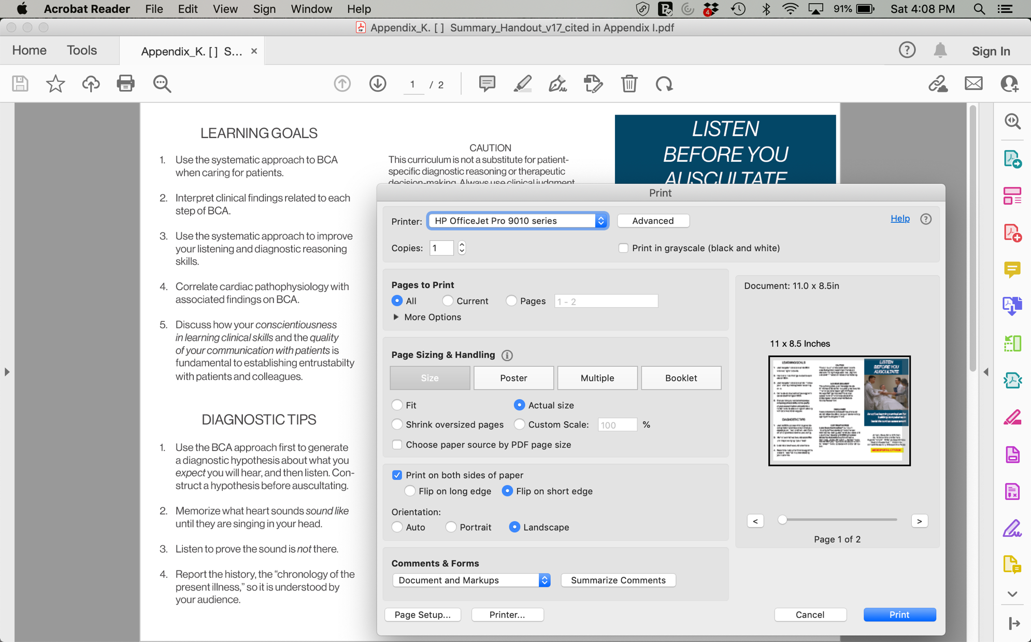

Image of “Listen Before You Auscultate” brochure author-created and -owned.
Image of print dialogue box owned by Adobe and used with permission.

